NEVER GONNA GIVE YOU UPS

project charter
Version 1.1
09/14/2022

VERSION HISTORY
Version # | Implemented  By | Revision  Date | Approved  By | Approval  Date | Reason
1.0 | Destinee Matsoumou | 9/11/2022 | Destinee Matsoumou | 9/11/2022 | Creation and initial editing
1.1 | Zach Gonzalez | 9/14/2022 | Zach Gonzalez, Alex Bovey | 9/14/2022 | Addition of Executive Summary, Goals & Objectives, SOW, Success Criteria, Approach, Scope, Dependencies, Risks
UP Template Version: 11/30/06
TABLE OF CONTENTS
1 Introduction 4
1.1 Executive Summary 4
2 Justification 4
2.1 Business Need 4
2.2 Business Impact 4
3 System Objectives and Scope Management 4
3.1 Objectives 4
3.2 Scope 4
3.3 Requirements 4
3.4 Major Deliverables 6
3.5 Boundaries 6
4 Duration 6
4.1 Timeline 6
• Deliverable 1: OCT 24 6
• Deliverable 2: NOV 14 6
• Final Deliverable: Dec 05 6
4.2 Milestones 6
4.3 Statement of Work 7
4.4 Success Criteria 7
5 budget Estimate 7
5.1 Funding Source 7
5.2 Estimate 7
Assumptions, Constraints, and Dependencies 8
5.3 Assumptions 8
5.4 Constraints 8
5.5 Dependencies 8
5.6 Risks 8
6 Project Organization 9
6.1 Roles and Responsibilities 9
6.2 Approach 9
6.3 Stakeholders (Internal and External) 9
7 project Charter approval 10
APPENDIX A: REFERENCES 11
APPENDIX B: KEY TERMS 12
APPENDIX C: GOALS 13

Introduction

Executive Summary
The purpose of the project charter is to outline the Thompson Project to create a shared understanding of its goal, objectives, and resources requirements before the project is scoped out in detail. This document will oversee goals and objectives, a Statement of Work, important milestones, the success criteria, the approach, scope, assumptions, constraints, dependencies, and risks. The goal of this project is to develop a website for the Thompson Project. The website is set to be due and completed on the date of 12/05/22.

Justification

Business Need
A Website is needed for the project to grow and expand as well as reach an audience. As the Thompson Project is a nonprofit a website is a requirement in the technology day in and age to receive funds and connect with those interested in volunteering.

Business Impact
Collection of funds and the receiving of volunteers. As well as the storing of information for juveniles once they leave the detention center.

System Objectives and Scope Management

Objectives
The objectives of the Thompson Project are as follows:
- Solicit the organization and organizational events publicly; provide the user with options for donations
- Provide a database for accounting and recordkeeping
- Provide the community with information and resources involving the Thompson Project and its mission
- Provide the user with a secure payment process for donations; Maintain data safety and integrity as a high priority.

Scope

A website that will be used for volunteering and helping kids in detention centers. Guests will be able to sign up for volunteering opportunities. It will include a calendar/event date so visitors will know locations to visit and activities happening. A donation page for both money and product donations will be included.

Requirements
The following table presents the requirements that the project’s product, service, or result must meet for the project objectives to be satisfied.
- The system will create user accounts.
- The system will edit user accounts.
- The system will delete user accounts.
- The system will create admin accounts.
- The system will edit admin accounts.
- The system will delete admin accounts.
- The system will create volunteer accounts.
- The system will edit volunteer accounts.
- The system will delete volunteer accounts.
- The system will allow account log-ins.
- The system will grant user privileges based on account type.
- The system will create news.
- The system will edit news.
- The system will delete news.
- The system will create grant proposals.
- The system will edit grant proposals.
- The system will delete grant proposals.
- The system will create events.
- The system will edit events.
- The system will delete events.
- The system will have a calendar.
- The system will update the calendar with news and events.
- The system will allow users to donate using the donation page.
- The system will display drop off locations for physical items.
- The system will provide a log-in page for created accounts.
- The system will provide a search bar.
- The system will edit payments.
- The system will delete payments.
- The system will add testimonials.
- The system will edit testimonials.
- The system will delete testimonials.
- The system will have an about us page.
- The system will edit the about us page.
- The system will delete the about us page.
- The system will add resources for juveniles.
- The system will edit resources for juveniles.
- The system will allow resources to be deleted.
- The system will add pictures to the carousel.
- The system will allow editing of photos in the carousel.
- The system will allow photos to be deleted from the carousel.
- The system will allow organization accounts to be added.
- The system will allow organization accounts to be edited.
- The system will allow organization accounts to be deleted.
- The system will allow contact information to be added.
- The system will allow contact information to be edited.
- The system will allow contact information to be deleted.
- The system will allow users to join events.
- The system will edit attendees.
- The system will delete attendees.
- The system will conduct backups.
- The system will be capable of recovery.
- The system will create a donors list.
- The system will edit a donors list.
- The system will delete a donors list.
- The system will create a volunteer list.
- The system will edit a volunteer list.
- The system will delete a volunteer list.
- The system will be designed and implemented with WordPress.
- The system will include a MySQL server for database management.
- The system will use IBM Cloud for storage and backups.
- The system will be user-friendly by providing a simple navigation experience and a satisfactory balance between text and images.
- The system will provide the admin with volunteer, donation, and event information for easy scheduling.
- The systems will be online and accessible at all times, unless maintenance requires the system to be temporarily offline.
- The system will be accessible on desktop and most mobile browsers.

Major Deliverables
The following table presents the major deliverables that the project’s product, service, or result must meet for the project objectives to be satisfied.
Major Deliverable | Deliverable Description
Demo 1 | 50% of project completed
Demo 2 | 75% of project completed
Final Demo | Full project is Completed

Boundaries
The Boundaries of the Thompson Project are closely related to the project's objectives. This is a parameter established on what we will do and will not do. Some important ones:
1. We will not allow scope creep
2. We will remain within our budget.
3. We will work with a strict timeline, nothing outside business hours.
4. We will only use the technology specified previously.
5. We will only do tasks we are qualified to do, nothing outside our expertise.

Duration

Timeline

Deliverable 1: OCT 24

Deliverable 2: NOV 14

Final Deliverable: Dec 05

Milestones
The table below lists the high-level Milestones of the project and their estimated completion timeframe.
Milestones | Estimated Completion Timeframe
Complete demo 1 | 10/24/2022
Complete demo 2 | 11/14/2022
Final demo | 12/11/2022

Statement of Work

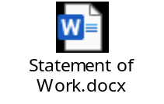

Success Criteria
In order to reach completion, the system must be fully functional and meet all business needs and requirements as defined by Armond Thompson, the Black Hat Slackers, and Tan Tabletop teams.

budget Estimate

Funding Source
Funding will not be provided from an outside source

Estimate
This section provides a summary of estimated spending to meet the objectives of the Thompson Project as described in this project charter. This summary of spending is preliminary and should reflect costs for the entire investment lifecycle. It is intended to present probable funding requirements and to assist in obtaining budget support.
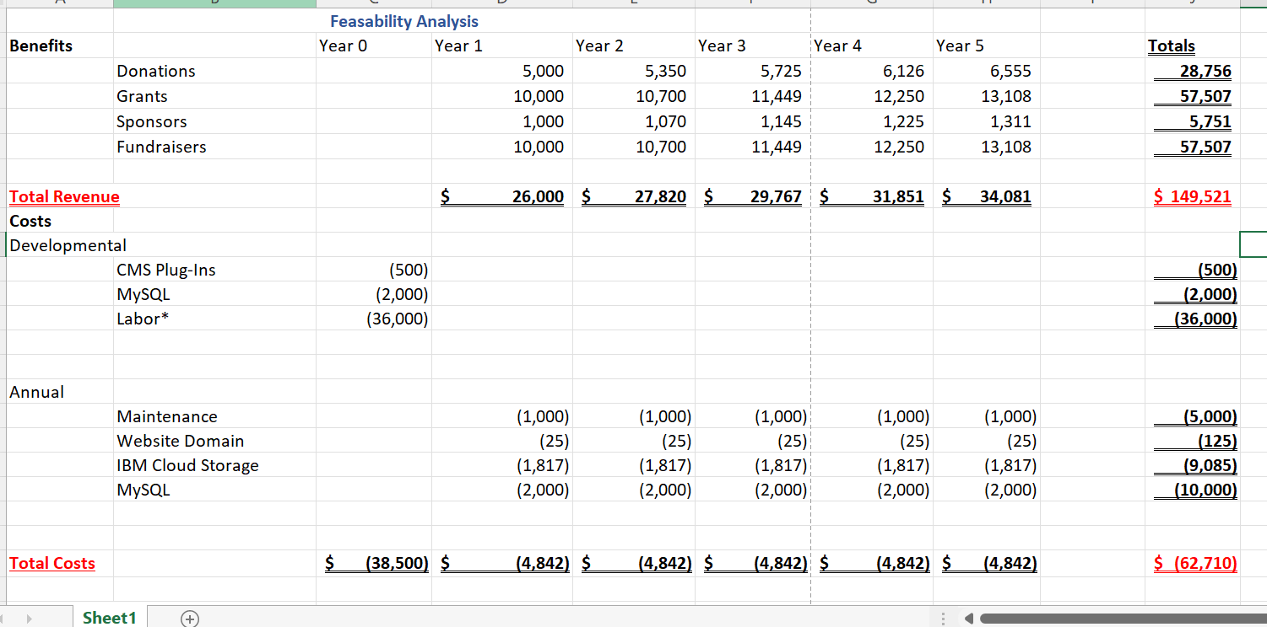

Assumptions, Constraints, and Dependencies

Assumptions
This section identifies the statements believed to be true and from which a conclusion was drawn to define this project charter.
- Users will enter their information into the system to register as volunteers.
- Users will create an account from the login page.
- Project team has necessary skills to complete

Constraints
This section identifies any limitation that must be taken into consideration prior to the initiation of the project.

- The team may not meet the deadline due to planned change of events
- The team may run out of funds for the project
- The team may deal will time constraints concerning due dates

Dependencies
A major dependency is account creation. For admins, they will need to sign into their account to be able to add pictures to the carousel, add or edit events, etc... Account creation will also be needed for the public to sign up for events, send donations, to add contact information to their account, etc...

Risks
Risk | Mitigation
Timeliness | Work to meet every deadline on time.
Budgeting | Stick to budget to avoid overspending
Scope creep | Have a written contract
Password Breach | Require 8 characters, uppercase, lowercase, number, and special character.
Financial Information | Utilize 3rd party software, NEVER store confidential user data

Project Organization

Roles and Responsibilities
This section describes the key roles supporting the project.
Name & Organization | Project Role | Project Responsibilities
<Armond Thompson>  <Thompson Project> | Project Sponsor | Responsible for approving the project at various stages.
 | Project Manager | Responsible for the project in its entirety.
 | Requirement analyst | Analyze requirements for a project and determine how to translate clients' vision into a plan that can be implemented by developers.
 | System Architects and Analysts | Responsible for creating the hardware, software, and network system to meet the requirements of client.
 | Developers | Responsible for developing, coding, installing, and maintaining software systems.

Approach
Our scrum team will utilize an agile approach to complete project milestones and deliver a final product that meets the requirements and expectations of the Thompson Project.

Stakeholders (Internal and External)
The stakeholder for this project is the development team and the sponsor of the Thompson Project

project Charter approval
The undersigned acknowledge they have reviewed the project charter and authorized and funded the Thompson Project. Changes to this project charter will be coordinated with and approved by the undersigned or their designated representatives.

Signature: |  | Date:
Print Name:
Title:
Role:

Signature: |  | Date:
Print Name:
Title:
Role:

Signature: |  | Date:
Print Name:
Title:
Role:

APPENDIX A: REFERENCES
The following table summarizes the documents referenced in this document.
Document Name and Version | Description | Location
Black hat slackers | Elaboration spec from cis 320 class | https://blackboard.louisville.edu/webapps/discussionboard/do/message?action=list_messages&course_id=_1685341_1&nav=discussion_board_entry&conf_id=_545437_1&forum_id=_511819_1&message_id=_8210835_1

APPENDIX B: KEY TERMS
[Insert terms and definitions used in this document. Add rows to the table as necessary. Follow the link below to for definitions of project management terms and acronyms used in this and other documents.
http://www2.cdc.gov/cdcup/library/other/help.htm
The following table provides definitions for terms relevant to this document.
Term | Definition
[Insert Term] | [Provide definition of the term used in this document.]
[Insert Term] | [Provide definition of the term used in this document.]
[Insert Term] | [Provide definition of the term used in this document.]

APPENDIX C: GOALS

