Use Cases
Use-Case Name: AddVolunteer

ID: UC1

Importance: High

Primary Actor: User

Preconditions:
- The user wishes to sign up as a volunteer.
Flow of Events:
- Use case starts when the user clicks on the “Volunteer” tab and is sent to the “Volunteer Application Form.”
- System displays a set of inquiries as follows for the user to fill out.
- User inputs ‘First Name’.
- User inputs ‘Last Name’.
- User inputs ‘DOB’ (mm/dd/yyyy).
- User inputs ‘Email Address’.
- User inputs ‘Phone Number’.
- User clicks ‘Day Availability’.
- User clicks ‘Preferred Hours’.
- User clicks Submit.

Postconditions: The user is registered in database as new volunteer entity.

AddVolunteer Prototype
Sign In
Search Bar
Social Media
Donate Now
Thompson Foundation

Contact
About
Events
Volunteer
Home

Call to Action

First Name:
Last Name:
(mm/dd/yyyy)
Email:
DOB:
Phone #:
M T W Th F S Su
Day Availability:
to
Preferred Hours:

Submit

Thank You Message
Volunteer Class Diagram (Add)
This diagram shows the attributes and methods that are involved with class ‘Volunteer’. Attributes are listed in the second box and constitute ‘Volunteer’ data. Methods are listed in the third box and include actions the user takes to complete the main flow.

Volunteer
- First Name
- Last Name
- DOB (mm/dd/yyyy)
- Email Address
- Phone Number
- Day Availability
- Preferred Hours

Inputs
Clicks

AddVolunteer Sequence Diagram
This diagram shows the sequence of actions taken to complete each use case and the relationship of action between actor, class, and data store.
In this example, the diagram shows flows and relationships of ‘AddVolunteer’ between User, Volunteer, and Data Store.

Volunteer

User Class Data Store
First name
Last name
DOB
Email Address
Check for duplicate account via email matching
Phone Number
Day Availability
Data sent to Data Store
Preferred Hours

Sign-up Successful
1. User inputs ‘First Name’. 2. User inputs ‘Last Name’. 3. User inputs ‘DOB’ (mm/dd/yyyy). 4. User inputs ‘Email Address’. 5.User inputs ‘Phone Number’. 6. User clicks ‘Day Availability’ 7. User clicks ‘Preferred Hours’.

Use-Case Name: EditVolunteer

ID: UC2

Importance: High

Primary Actor: User

Preconditions:
- The user has an existing volunteer account.
- The user wishes to change their information in the database.
- The user is logged in.
- The user clicks the ‘Account’ tab.

Flow of Events:
- System displays current ‘First Name’, ‘Last Name’, ‘DOB’, ‘Email Address’, ‘Phone Number’, ‘Day Availability’ and ‘Preferred Hours’ data in text boxes.
- User inputs ‘First Name’.
- User inputs ‘Last Name’.
- User inputs ‘DOB’ (mm/dd/yyyy).
- User inputs ‘Email Address’.
- User inputs ‘Phone Number’.
- User clicks ‘Day Availability’.
- User clicks ‘Preferred Hours’.
- User clicks Submit.

Postconditions: Volunteer account information is edited in database.

EditVolunteer Prototype
Social Media
Thompson Foundation
Home
Volunteer
Events
About
Search Bar
Account
Donate Now

Contact

Account Information:

First Name
First Name:
Submit
Last Name
Last Name:
(mm/dd/yyyy)
(mm/dd/yyyy)
DOB:
Email
Email:
Phone #
Phone #:
M T W Th F S Su
Preferred Hours:
Day Availability:
to

Volunteer Class Diagram (Edit)
This diagram shows the attributes and methods that are involved with class ‘Volunteer’. Attributes are listed in the second box and constitute volunteer data to be edited. Methods are listed in the third box and include actions the user takes to complete the main flow.

Volunteer
- First Name
- Last Name
- DOB (mm/dd/yyyy)
- Email Address
- Phone Number
- Day Availability
- Preferred Hours

Inputs
Clicks

EditVolunteer Sequence Diagram
This diagram shows flows and relationships of ‘EditVolunteer’ between User, Volunteer, and Data Store.

Volunteer

User Class Data Store
First name

1. User inputs ‘First Name’. 2. User inputs ‘Last Name’. 3. User inputs ‘DOB’ (mm/dd/yyyy). 4. User inputs ‘Email Address’. 5.User inputs ‘Phone Number’. 6. User clicks ‘Day Availability’ 7. User clicks ‘Preferred Hours’.

Sign-up Successful
Check for duplicate account via email matching
Data sent to Data Store
Preferred Hours
Day Availability
Phone Number
Email Address
DOB
Last name
Use-Case Name: DeleteVolunteer

ID: UC3

Importance: High

Primary Actor: Admin

Preconditions:
- Admin wishes to remove volunteer entity from database.
- Admin is logged in.
- Admin goes to ‘Volunteer’ tab.
Flow of Events:
- Admin inputs email of account to be deleted.
- Admin clicks Search.
- System displays current ‘First Name’, ‘Last Name’, ‘DOB’, ‘Email Address’, ‘Phone Number’, ‘Day Availability’ and ‘Preferred Hours’ data in text boxes.
- Admin clicks ‘Delete Account’.
- Admin clicks ‘Confirm’ on pop-up text box.
Postconditions: The volunteer account is removed from the database.

DeleteVolunteer Prototype (Admin view)
Search Bar
Thompson Foundation
Home
Volunteer
Events
About
Contact
Social Media
Account
Donate Now

Search for Account by Email:
Search

Email:
Phone #:
First Name:
Last Name:
to
Preferred Hours:
Day Availability:
DOB:
(mm/dd/yyyy)

M T W Th F S Su

Delete
Submit

(Pop-up displays after clicking Delete.)

Confirm Deletion of Account?
Cancel
Confirm
Volunteer Class Diagram (Delete)
This diagram shows the attributes and methods that are involved with class ‘Volunteer’. Attributes are listed in the second box and constitute volunteer data. Methods are listed in the third box and include admin actions taken to complete the main flow.

Volunteer
- First Name
- Last Name
- DOB (mm/dd/yyyy)
- Email Address
- Phone Number
- Day Availability
- Preferred Hours

Clicks

DeleteVolunteer Sequence Diagram
This diagram shows flows and relationships of ‘DeleteVolunteer’ between Admin, Volunteer, and Data Store.

Volunteer

Admin Class Data Store
Find account via email matching
Email Address
Account found; sends volunteer data

Verify delete request
Request Delete
Verify delete request
Account deleted
Delete confirmed

Account deleted successfully
- Admin inputs email of account to be deleted. 2. System displays current ‘First Name’, ‘Last Name’, ‘DOB’, ‘Email Address’, ‘Phone Number’, ‘Day Availability’ and ‘Preferred Hours’ data in text boxes. 3. Admin clicks ‘Delete Account’. 4. Admin clicks ‘Confirm’ on pop-up text box.

Use Case Diagram

The Use-Case Diagram reveals who is doing the action within the use-case flow. For the sake of these diagrams, “Create” and “Add” are synonymous.
In this diagram, the user is the primary actor for AddVolunteer and EditVolunteer, allowing the user to create and edit their own volunteer information. The system admin is the primary actor for DeleteVolunteer, granting the administrator privileges to remove a volunteer entity from the database.

Volunteer Management System

AddVolunteer

EditVolunteer

User DeleteVolunteer Admin

Use-Case Name: AddDonorInfo

ID: UC4

Importance: High

Primary Actor: User

Preconditions:
- The user is on the ‘Donation’ form of the website.
- The user wishes to donate.
- The user has an email address.
- The user is capable of completing a transaction through PayPal.
- The user wishes to submit their name for organization records (optional).
Flow of Events:
- User clicks DonationAmount.
- User clicks PaymentPreference.
- User inputs FirstName.
- User inputs LastName.
- User inputs EmailAddress.
- User clicks Donate, Physical Donation, or Subscription.
- User clicks Submit.

Postconditions:
- Third-party payment software (PayPal) prompts user to complete donation.
- Pop-up thanks user for donation.

AddDonorInfo Prototype
Donate Now
Sign In
Search Bar
Social Media
Contact
About
Events
Volunteer
Home
Thompson Foundation

Call to Action

Donation Amount: $1 $5 $10 $15 $20 $50 Other:

Payment Preference: One Time OR Monthly

(Optional)
First Name:
Last Name:

Email:
Submit

By clicking Submit, you will be re-directed to PayPal’s transaction services

Donation Class Diagram (Add)
This diagram shows the attributes and methods that are involved with class ‘Donation’. Attributes are listed in the second box and constitute ‘Donation’ data. Methods are listed in the third box and include actions the user takes to complete the main flow.

Donation
- DonationAmount
- PaymentPreference
- FirstName
- LastName
- EmailAddress

Clicks
Inputs

AddDonorInfo Sequence Diagram
This diagram shows the sequence of actions taken to complete each use case and the relationship of action between actor, class, and data store.
This diagram shows flows and relationships of ‘AddDonorInfo’ between User, Donation, and Data Store.

Donation

User Class Data Store
DonationAmount
Donation processed successfully
Donation information stored
FirstName
LastName
Email Address
- User clicks DonationAmount.
- User clicks PaymentPreference.
- User inputs FirstName.
- User inputs LastName.
- User inputs EmailAddress.

PaymentPreference

Use-Case Name: EditDonorInfo

ID: UC5

Importance: High

Primary Actor: Admin

Preconditions:
- The admin is logged in.
- The admin wishes to edit donation information.
- The admin is on the ‘Donation’ form of the website.
- The admin is on the ‘Access Donation History’ form.

Flow of Events:
- Admin inputs EmailAddress (of donation needing revision).
- Admin inputs DonationAmount (of donation needing revision).
- Admin clicks Search.
- System returns Donation.
- Admin inputs DonationAmount.
- Admin inputs PaymentPreference.
- Admin inputs FirstName.
- Admin inputs LastName.
- Admin inputs EmailAddress.
- Admin clicks Submit.
Postconditions:
- The donation data has been revised (i.e. amount of donation, type of donation, donator first name/ last name/ email address).
- Donation data integrity is maintained.
EditDonorInfo Prototype
(Admin View)
Donate Now
Thompson Foundation
Home
Volunteer
Events
About
Contact
Search Bar
Account
Social Media

Search for Transaction:
Email:
Donation Amount:
Search

Donation Amount:
Payment Preference:
Email:

First Name:
Last Name:

Delete
Submit

Donation Class Diagram (Edit)
This diagram shows the attributes and methods that are involved with class ‘Donation’. Attributes are listed in the second box and constitute ‘Donation’ data. Methods are listed in the third box and include actions the user takes to complete the main flow.

Donation
- DonationAmount
- PaymentPreference
- FirstName
- LastName
- Email

Clicks
Inputs

EditDonorInfo Sequence Diagram
This diagram shows flows and relationships of ‘EditDonorInfo’ between Admin, Donation, and Data Store.

Donation

Admin Class Data Store

- Admin inputs EmailAddress.
- Admin inputs DonationAmount.
- System returns Donation.
- Admin clicks DonationAmount.
- Admin clicks PaymentPreference.
- Admin inputs FirstName.
- Admin inputs LastName.
- Admin inputs EmailAddress.

Changes saved successfully
Email Address
LastName
FirstName
PaymentPreference
DonationAmount
EmailAddress
DonationAmount
Donation Found & Returned

Found Donation via Email, Donation Amount

Use-Case Name: DeleteDonorInfo

ID: UC6

Importance: High

Primary Actor: Admin

Preconditions:
- The admin is logged in.
- The admin wishes to delete donation information.
- The admin is on the ‘Donation’ form of the website.
- The admin is on the ‘Access Donation History’ form.

Flow of Events:
- Admin inputs EmailAddress (of donation to be deleted).
- Admin inputs DonationAmount (of donation to be deleted).
- System returns Donation.
- Admin clicks ‘DeleteTransaction’.
- Admin clicks ‘ConfirmDeleteTransaction’.

Postconditions:
- The donation data has been revised (i.e. amount of donation, type of donation, donator first name/ last name/ email address).
- Donation data integrity is maintained.

DeleteDonorInfo
(Admin view)
Social Media
Thompson Foundation
Home
Volunteer
Events
About
Contact
Search Bar
Account
Donate Now

Search For Transaction:
Email:
Donation Amount:
Search

Donation Amount:
Payment Preference:
Email:
First Name:
Last Name:
Delete
Submit

(Pop-up displays after clicking Delete.)
Cancel
Confirm Deletion of Donation?
Confirm

Donation Class Diagram (Delete)
This diagram shows the attributes and methods that are involved with class ‘Donation’. Attributes are listed in the second box and constitute ‘Donation’ data. Methods are listed in the third box and include actions the user takes to complete the main flow.
Donation
- DonationAmount
- EmailAddress

Clicks
Inputs

DeleteDonorInfo Sequence Diagram
This diagram shows flows and relationships of ‘DeleteDonorInfo’ between Admin, Donation, and Data Store.

Donation

Admin Class Data Store
Found Donation via Email, Donation Amount
EmailAddress
DonationAmount

- Admin inputs EmailAddress (of donation to be deleted).
- Admin inputs DonationAmount (of donation to be deleted).
- System returns Donation.
- Admin clicks ‘DeleteTransaction’.
- Admin clicks ‘ConfirmDeleteTransaction’.
Donation Deleted
Successfully
Donation Deleted
ConfirmDelete
Transaction
DeleteConfirmation
Request
DeleteTransaction
Donation Found & Returned

Use Case Diagram
The Use-Case Diagram reveals who is doing the action within the use-case flow. For the sake of these diagrams, “Create” and “Add” are synonymous.
In this diagram, the user is the primary actor for AddDonorInfo, allowing the user to add their own information as donor after donating. The system admin is the primary actor for EditDonorInfo and DeleteDonorInfo, granting the administrator privileges to edit and delete donation information.

Donation Management System

AddDonorInfo

EditDonorInfo

User DeleteDonorInfo Admin
Use-Case Name: AddCalendarEvent

ID: UC7

Importance: High

Primary Actor: Admin

Preconditions:
- The admin is logged in.
- The website calendar is functional.
- The admin wishes to add a new event into the website calendar.

Flow of Events:
- Admin inputs EventName.
- Admin inputs Date.
- Admin inputs Time.
- Admin inputs ShortDescription.
- Admin clicks Submit.

Postconditions:
- Calendar is up-to-date.

AddCalendarEvent
(Admin view)
Donate Now
Account
Search Bar
Social Media
Contact
About
Events
Volunteer
Home
Thompson Foundation

Event to Be Modified is Selected

Submit
Event
Event Name:
Day of Event: month day
Time of Event:
Brief Description:

Delete
Event

Calendar Class Diagram (Add)
This diagram shows the attributes and methods that are involved with class ‘Calendar’. Attributes are listed in the second box and constitute ‘Calendar’ data. Methods are listed in the third box and include actions the user takes to complete the main flow.

Calendar
- EventName
- Date
- Time
- ShortDescription
Inputs

AddCalendarEvent Sequence Diagram
This diagram shows flows and relationships of ‘AddCalendarEvent’ between Admin, Calendar, and Data Store.

Calendar

Admin Class Data Store
Event Added Successfully
Event Added
ShortDescription
Time
Date
EventName

- Admin inputs EventName.
- Admin inputs Date.
- Admin inputs Time.
- Admin inputs
ShortDescription.
- Admin clicks Submit.

Use-Case Name: EditCalendarEvent

ID: UC8

Importance: High

Primary Actor: Admin

Preconditions:
- The admin is logged in.
- The admin wishes to edit an event in the website calendar.
- The website calendar is functional.
- The website calendar has events already logged.
- Admin navigates to interactable Calendar.
- Admin clicks the event to edit.
Flow of Events:
- Admin inputs EventName.
- Admin inputs Date.
- Admin inputs Time.
- Admin inputs ShortDescription.
- Admin clicks Submit.

Postconditions:
- Calendar Event is edited.
- Calendar is accurate.

EditCalendarEvent
(Admin View)
Social Media
Donate Now
Account
Search Bar
Contact
About
Events
Volunteer
Home
Thompson Foundation

Event to Be Modified is Selected
Submit
Event
Event Name:
Day of Event: month day
Time of Event:
Brief Description:

Delete
Event

Calendar Class Diagram (Edit)
This diagram shows the attributes and methods that are involved with class ‘Calendar’. Attributes are listed in the second box and constitute ‘Calendar’ data. Methods are listed in the third box and include actions the user takes to complete the main flow.
Calendar
- EventName
- Date
- Time
- ShortDescription
Inputs

EditCalendarEvent Sequence Diagram
This diagram shows flows and relationships of ‘EditCalendarEvent’ between Admin, Calendar, and Data Store.

Calendar

Admin Class Data Store
EventName

Date
Time

- Admin inputs EventName.
- Admin inputs Date.
- Admin inputs Time.
- Admin inputs
ShortDescription

Event Successfully Changed
Event Changed
Event Added Successfully
ShortDescription

Use-Case Name: DeleteCalendarEvent

ID: UC9

Importance: High

Primary Actor: Admin

Preconditions:
- Admin is logged in.
- Admin wishes to edit an event in the website calendar.
- Calendar is functional.
- Calendar has events already logged.
- Admin navigates to interactable Calendar.
- Admin clicks the event to delete
Flow of Events:
- Admin clicks ‘DeleteEvent’.
- Admin clicks ‘ConfirmEventDelete’.
Postconditions:

- Event is removed.
- Calendar is accurate.

DeleteCalendarEvent
(Admin view)
Donate Now
Account
Search Bar
Social Media
Contact
About
Events
Volunteer
Home
Thompson Foundation

Event to Be Modified is Selected
Submit
Event
Event Name:
Day of Event: month day
Time of Event:
Brief Description:

Delete
Event

(Pop-up displays after clicking Delete Event)
Confirm Deletion of Event?
Cancel
Confirm
Calendar Class Diagram (Delete)
This diagram shows the attributes and methods that are involved with class ‘Calendar’. Attributes are listed in the second box and constitute ‘Calendar’ data. Methods are listed in the third box and include actions the user takes to complete the main flow.
Calendar
- DeleteEvent
- ConfirmEventDelete
Click

DeleteCalendarEvent Sequence Diagram
This diagram shows flows and relationships of ‘DeleteCalendarEvent’ between Admin, Calendar, and Data Store.

Calendar

Admin Class Data Store

DeleteEvent
- Admin clicks ‘DeleteEvent’.
- Admin clicks ‘ConfirmEventDelete’.

Event Successfully Deleted
Event Deleted
DeleteEvent Confirmed
ConfirmEventDelete

Use Case Diagram
The Use-Case Diagram reveals who is doing the action within the use-case flow. For the sake of these diagrams, “Create” and “Add” are synonymous.
In this diagram, the admin has exclusive privileges to Add, Edit, and Delete CalendarEvents use cases. The website Calendar is essential to communicating important dates and events with the public, meaning the admin should exclusively have the right to modify the Calendar.

Calendar Management System

AddCalendarEvent

EditCalendarEvent

DeleteCalendarEvent Admin

Comprehensive Class Diagram
Volunteer (Add/Edit/Delete)
- First Name
- Last Name
- DOB (mm/dd/yyyy)
- Email Address
- Phone Number
- Day Availability
- Preferred Hours
Inputs
Clicks
Allows management of Donation class
Allows management of Volunteer class; has all necessary methods and attributes
Donation (Delete)
- DonationAmount
- EmailAddress

Clicks
Inputs

Calendar (Add/Edit)
- EventName
- Date
- Time
- ShortDescription
Inputs
Calendar (Delete)
- DeleteEvent
- ConfirmEventDelete
Click

Donation (Add/Edit)
- DonationAmount
- PaymentPreference
- FirstName
- LastName
- EmailAddress

Clicks
Inputs

Existing accounts may be deleted

Allows management of Calendar class

Existing accounts may be deleted

UC10. Add Photos into Photo Carousel

Description: The system will allow administrators to add photos to the photo carousel page on the Thompson Project website.

Flow of Events:
- The system will allow administrator access.
- The administrator will access photo carousel page.
- The administrator will click add picture button.
- The administrator will select picture from local files on PC.
- The administrator will confirm picture to be added.
- The administrator will save photo carousel page.
- END USE CASE

c. Special Requirements:

Administrator must have internet and system access.

The administrator also needs to have the pictures saved on their PC.

d. Pre-conditions:
- Administrators will need access to the system

Post-conditions:

Administrators will need to be able to save the photos on the webpage.

UC11. Edit Photos in Photo Carousel

Description: The system will allow administrators to edit photos that are on photo carousel page on the Thompson Project website.

b. Flow of Events:
- The system will allow administrator access.
- The administrator will access photo carousel page.
- The administrator will find the photo they wish to edit.
- The administrator will select picture to be edited.
- The administrator will make changes to the photo such as captions.
- The administrator will confirm changes on photo carousel page.
- END USE CASE

c. Special Requirements:

Administrator must have internet and system access.

Pre-conditions:

Administrators will need access to the system.

The photos need to be already on the webpage.

e. Post-conditions:

Administrators will need to be able to save the photos changes on the webpage.

UC12. Delete Photos From Photo Carousel

Description: The system will allow administrators to delete photos to the photo carousel page on the Thompson Project website.

Flow of Events:
- The system will allow administrator access.
- The administrator will access the photo carousel page.
- The administrator will find the photo they want to delete.
- The administrator will click on delete picture button.
- The administrator will confirm they want the picture deleted.
- The administrator will save photo carousel page.
- END USE CASE

Special Requirements:

Administrator must have internet and system access.

Pre-conditions:

Administrators will need access to the system.

The administrator also needs to have the photo already posted on the photo carousel webpage.

Post-conditions:

Administrators will need to be able to save the changes to photo carousel on the webpage.

UC13. Create Volunteer Account

Description: The system will allow administrators to add volunteer accounts on the Thompson Project webpage so that the selected volunteers will be able to log into the system.

Flow of Events :
- The system will allow administrator access.
- The administrator will access create account.
- The administrator will click volunteer account.
- The administrator will enter full name.
- The administrator will enter DOB.
- The administrator will enter email address.
- The administrator will enter telephone number.
- The administrator will enter username.
- The administrator will save account information.
- The administrator will add volunteer account.
- END USE CASE

Special Requirements:

Administrator must have internet and system access. The administrator also needs to have the volunteer ID number to create the account.

d. Pre-conditions:

Administrators will need access to the system.

The volunteer will need to have completed application and approved. The volunteer must have an ID number

e. Post-conditions:

Administrators will need to be able to save account.

UC14. Edit Volunteer Account

Description: The system will allow volunteers to edit volunteer accounts on the Thompson Project webpage so that the selected volunteers will be able to have the most accurate information.

Flow of Events:
- The system will allow volunteer access.
- The volunteer will access volunteer account
- The volunteer will click volunteer account.
- The volunteer will enter full name.
- The volunteer will enter ID number.
- The volunteer will select gender.
- The volunteer will enter email address.
- The volunteer will enter telephone number.
- The volunteer will enter username.
- The volunteer will save account information.
- END USE CASE

Special Requirements:

Volunteer must have internet and system access.

The volunteer must have system access and their username.

Pre-conditions:

Volunteer will need access to the system.

The volunteer will need to have completed application and approved.

The volunteer must have an ID number

Post-conditions:

Volunteer will need to be able to save account.

UC15. Delete Volunteer Account

Description: The system will allow administrators to delete volunteer accounts on the Thompson Project webpage so that the selected volunteers will no longer have access to the system and be deleted from the database.

Flow of Events:
- The system will allow administrator access.
- The administrator will search volunteer’s account by volunteer’s information.
- The administrator will click on volunteer’s account.
- The administrator will delete volunteer’s account.
- The administrator will confirm they want to delete the volunteer account.
- The administrator will submit the deletion of the account.
- END USE CASE

Special Requirements:

Administrator must have internet and system access.

The administrator also needs to have the volunteer’s information.

Pre-conditions:

Administrators will need access to the system.

The administrator will need to know the volunteer’s information.

Post-conditions:

Administrators will need to be able to delete the volunteer’s account.

UC16. Create Administrator Account

Description: The system will allow administrators to add administrator accounts on the Thompson Project webpage so that the selected administrators will have access to the system.

Flow of Events:
- The system will allow administrator access.
- The administrator will access create account.
- The administrator will click administrator account.
- The administrator will enter full name.
- The administrator will enter ID number.
- The administrator will enter DOB.
- The administrator will enter email address.
- The administrator will enter telephone number.
- The administrator will enter username.
- The administrator will save account information.
- The administrator will add administrator account.
- END USE CASE

Special Requirements:

Administrator must have internet and system access.

The administrator also needs to have the administrator ID number to create the account.

Pre-conditions:

Administrators will need access to the system.

The administrator must have an ID number.

Post-conditions:

Administrators will need to be able to save administrator’s account.

UC17. Edit Administrator Account

Description: The system will allow administrator account owner to edit administrator accounts on the Thompson Project webpage so that the selected administrators will have the most updated information.

b. Flow of Events:
- The system will allow administrator access.
- The administrator will enter their credentials.
- The administrator will click administrator account.
- The administrator will edit full name.
- The administrator will edit ID number.
- The administrator will edit DOB.
- The administrator will edit gender.
- The administrator will edit email address.
- The administrator will edit telephone number.
- The administrator will edit username.
- The administrator will save account information.
- END USE CASE

c. Special Requirements:

Administrator must have internet and system access.

The administrator account owner will need to have their credentials to log into the system

d. Pre-conditions:

Administrators will need access to the system.

The administrator must have an ID number and already made account.

e. Post-conditions:

Administrators will need to be able to save administrator’s account.

UC18. Delete Administrator Account

Description: The system will allow administrators to delete other administrator’s accounts on the Thompson Project webpage so that the selected administrator will no longer have access to the system and be deleted from the database.

Flow of Events:
- The system will allow administrator access.
- The administrator will search administrator account by administrator information.
- The administrator will click on administrator’s account.
- The administrator will delete administrator’s account.
- The administrator will confirm they want to delete the administrator account.
- The administrator will submit the deletion of the account.
- END USE CASE

Special Requirements:

Administrator must have internet and system access.

The administrator also needs to have the other administrator’s information.

Pre-conditions:

Administrators will need access to the system.

The administrator will need to know the administrator’s information.

Post-conditions:

Administrators will need to be able to delete the administrator’s account.

Use Case Diagrams

- Admin adds pictures into carousel.
- Admin edits picture from the carousel.
- Admin deletes pictures from the carousel

This use-case diagram demonstrates any peronnel with administrative access to the upcoming webpage will be the only one to have control over adding, editing, and deleting any pictures from the photo carousel we are designing.
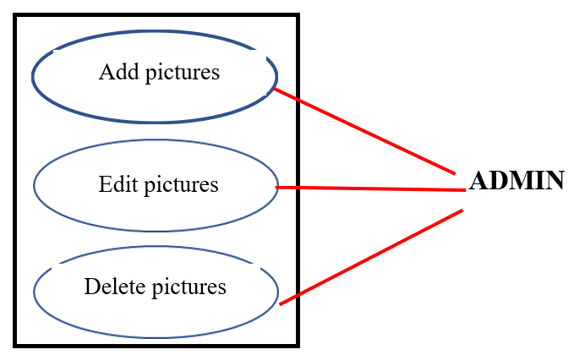

- Admin adds other administration accounts
- Admin owner edits their administration accounts
- Administration deletes administration accounts

The diagram below describes how administration has control in terms of adding and deleting the other admin accounts while the admin owner has control to edit their own account

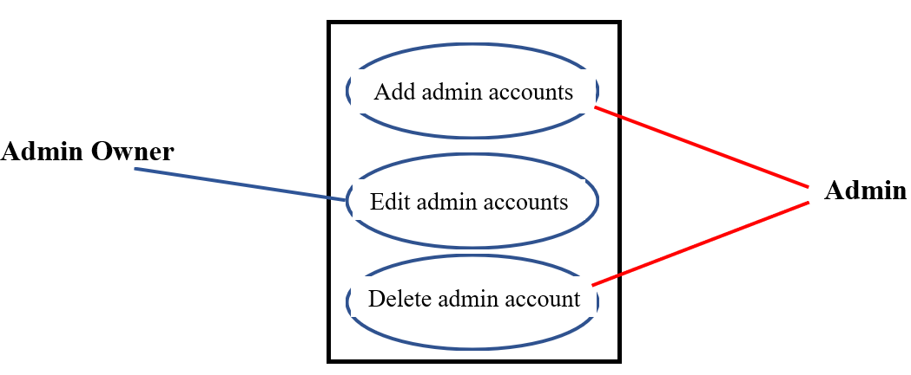

- Admin adds volunteer account
- Volunteer edits their volunteer account
- Admin deletes volunteer account

The use-case diagram shows that the admin will control adding and deleting volunteer accounts, but the volunteer account owner will have some editing capabilities.
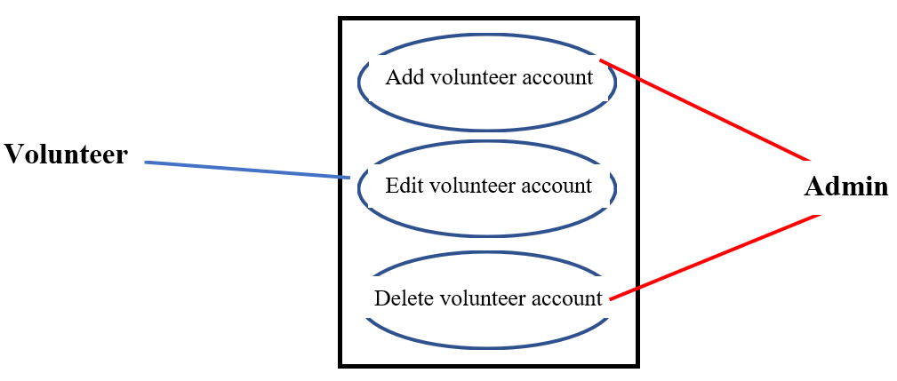

Use-Case Name: AddFollowerAccount

ID: UC19

Importance: Medium

Primary Actor: User

Preconditions:
- The user wishes to sign up as a follower.
Flow of Events:
- Use case starts when the user clicks on the “Contact” tab and is sent to the Contact page.
- System displays User Information spaces and “Email sign-up” button.
- User inputs ‘First Name’.
- User inputs ‘Last Name’.
- User inputs ‘DOB’ (mm/dd/yyyy).
- User inputs ‘Email Address’.
- User inputs ‘Phone Number’.
8. User clicks Submit.

Postconditions: The user is registered in database as new follower entity.

AddFollower Prototype
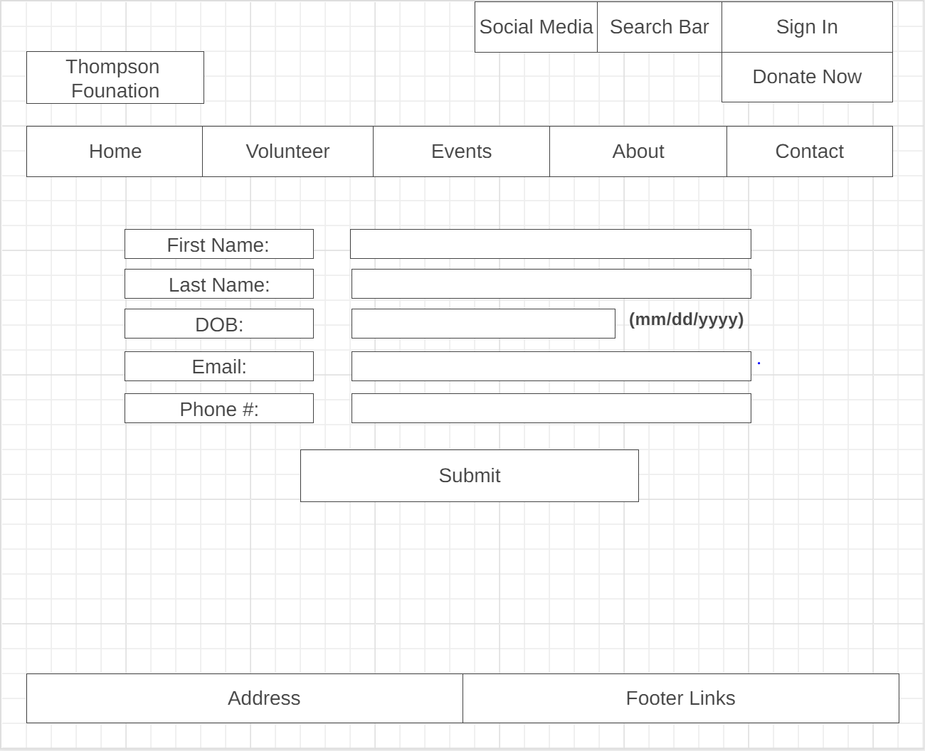

Follower Class Diagram (Add)
This diagram shows the attributes and methods that are involved with class ‘Follower’. Attributes are listed in the second box and constitute ‘Follower data. Methods are listed in the third box and include actions the user takes to complete the main flow.

Follower
- First Name
- Last Name
- DOB (mm/dd/yyyy)
- Email Address
- Phone Number
Inputs
Clicks

AddFollower Sequence Diagram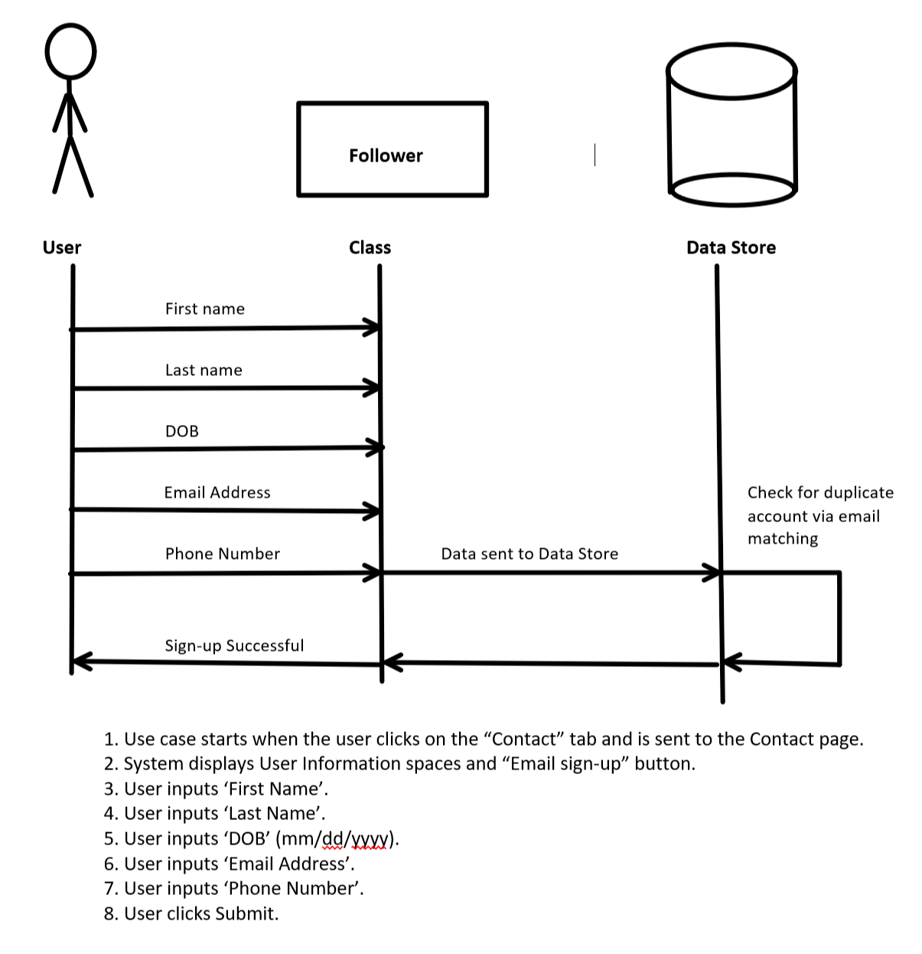

Use-Case Name: EditFollowerAccount

ID: UC20

Importance: Medium

Primary Actor: User

Preconditions:
  - The user has an existing follower account.
  - The user wishes to change their information in the database
  - The user is logged in
  - The user clicks the ‘Account’ tab

Flow of Events:
  - System displays current ‘First Name’, ‘Last Name’, ‘DOB’, ‘Email Address’, and ‘Phone Number’ data in text boxes.
  - User inputs ‘First Name’.
  - User inputs ‘Last Name’.
  - User inputs ‘DOB’ (mm/dd/yyyy).
5. User inputs ‘Email Address’.
6. User inputs ‘Phone Number’.
7. User clicks Submit.

Postconditions: Follower account information is edited in database.

EditFollower Prototype

Follower Class Diagram (Edit)
This diagram shows the attributes and methods that are involved with class ‘Follower’. Attributes are listed in the second box and constitute ‘Follower data. Methods are listed in the third box and include actions the user takes to complete the main flow.

Follower
- First Name
- Last Name
- DOB (mm/dd/yyyy)
- Email Address
- Phone Number
Inputs
Clicks

EditFollower Sequence Diagram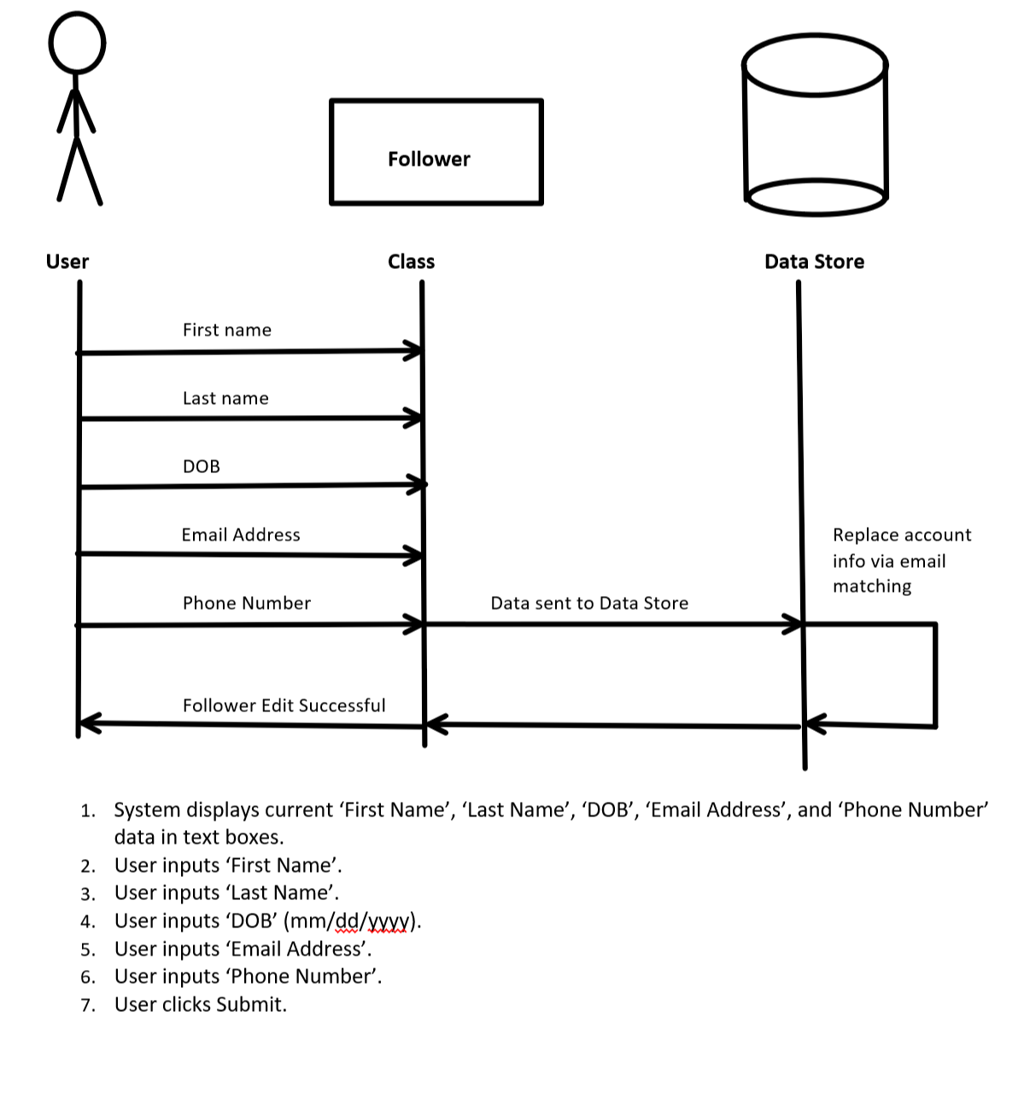

Use-Case Name: DeleteFollowerAccount

ID: UC21

Importance: Medium

Primary Actor: User

Preconditions:
1. The user has an existing follower account.
2. The user wishes to delete their account
3. The user is logged in
4. The user clicks the ‘Account’ tab

Flow of Events:
1. System displays current ‘First Name’, ‘Last Name’, ‘DOB’, ‘Email Address’, and ‘Phone Number’ data in text boxes.
2. User clicks ‘Delete Follower Account’
3. System displays confirmation box.
4. User clicks ‘Confirm’ on pop-up text box.

Postconditions: Follower account information is removed from database.

DeleteFollower Prototype
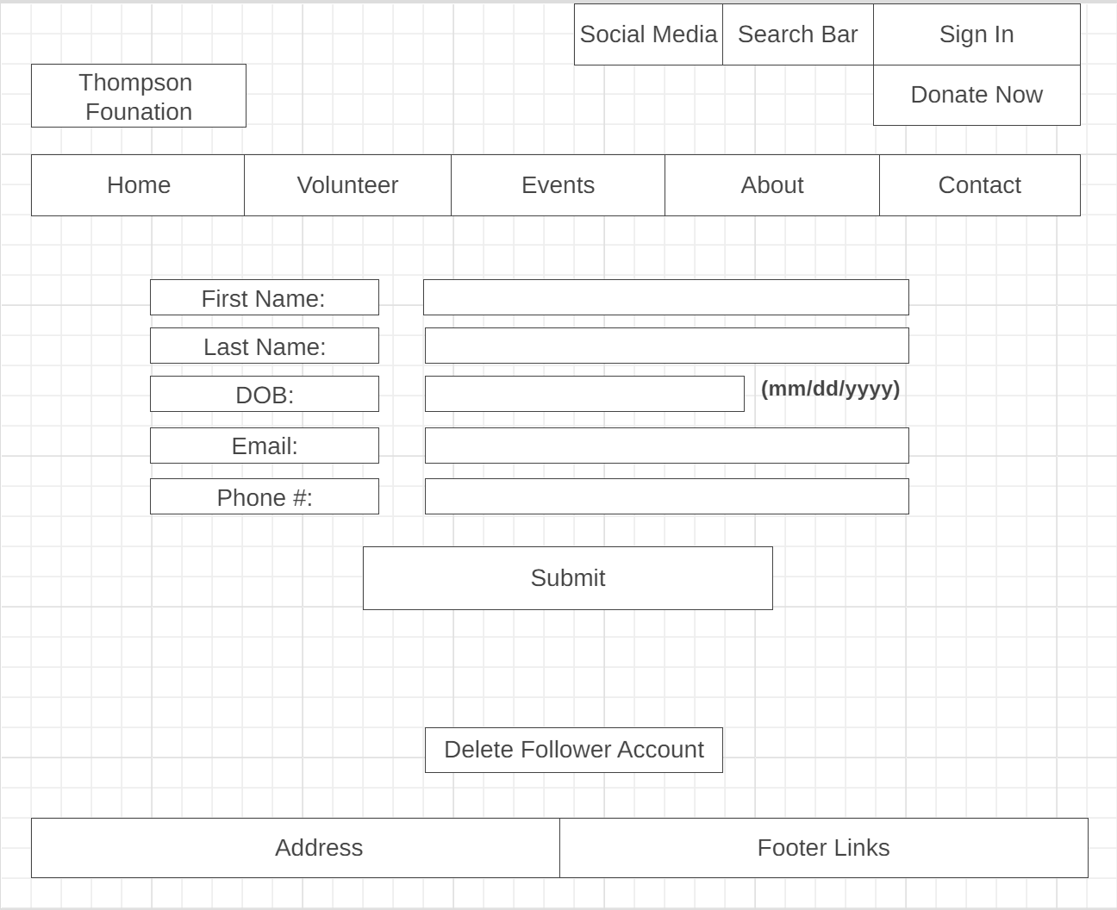

Follower Class Diagram (Delete)
This diagram shows the attributes and methods that are involved with class ‘Follower’. Attributes are listed in the second box and constitute ‘Follower data’. Methods are listed in the third box and include actions the user takes to complete the main flow.

Follower
- First Name
- Last Name
- DOB (mm/dd/yyyy)
- Email Address
- Phone Number
Clicks

Delete Follower Sequence Diagram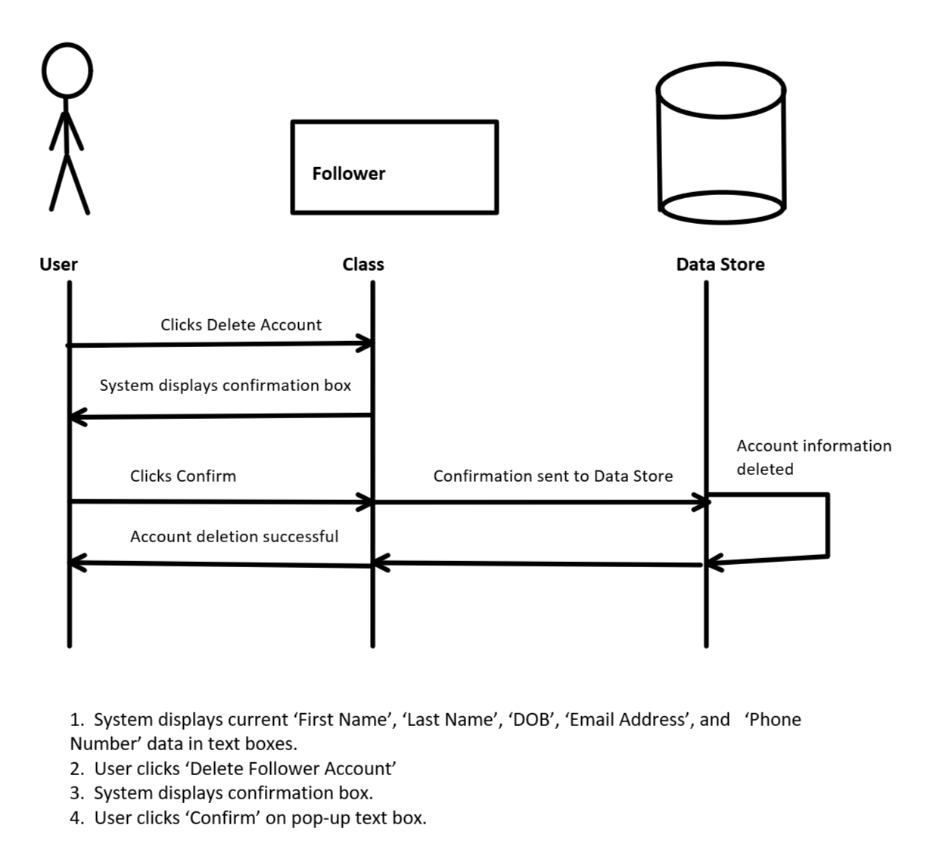

Use-Case Name: AllowLoginForOrganizationAccount

ID: UC2

Importance: High

Primary Actor: Admin

Preconditions: none

Flow of Events:
1. Admin clicks ‘Sign In’
2. Admin inputs ‘Username’.
3. Admin inputs ‘Password.
4. System recognizes Admin account
5. System allows Admin login
Postconditions: System displays admin view of website.

Allow Login Prototype
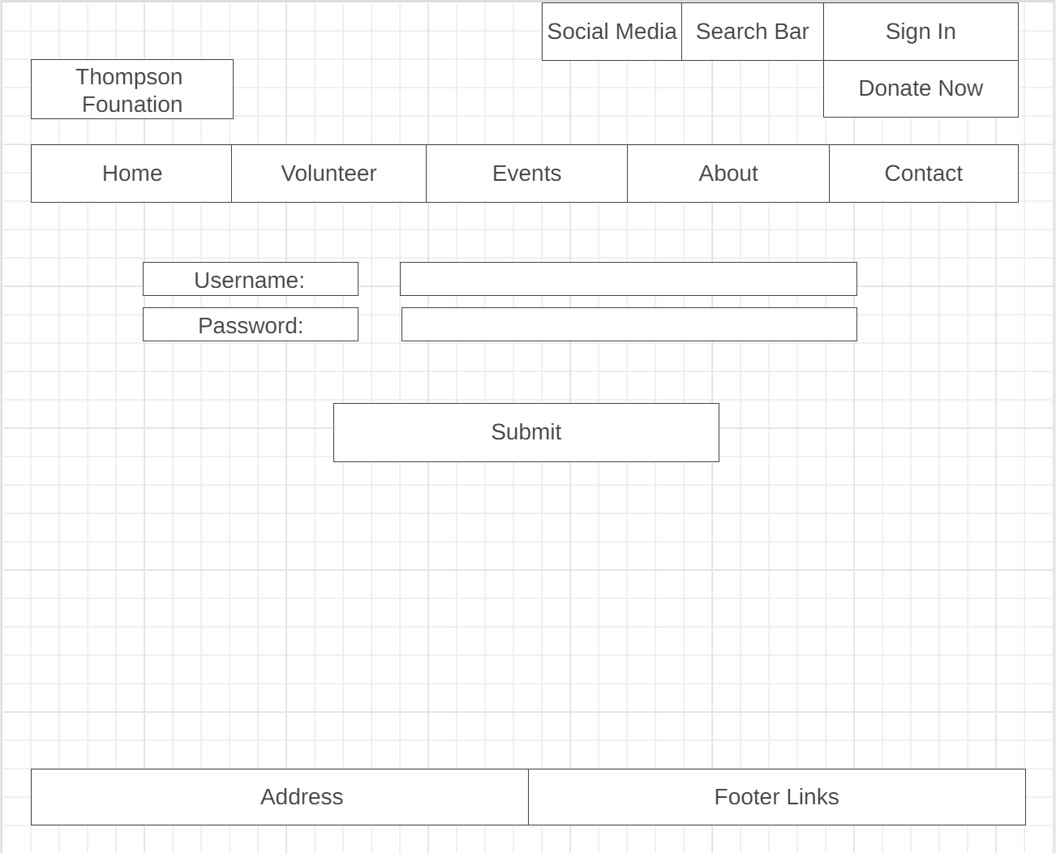

Allow Login Class Diagram
This diagram shows the attributes and methods that are involved with class ‘Allow Login For Organization Account’. Attributes are listed in the second box and constitute ‘Admin data’. Methods are listed in the third box and include actions the admin takes to complete the main flow.

Allow Login
- Username
- Password
Inputs
Clicks

Allow Login Sequence Diagram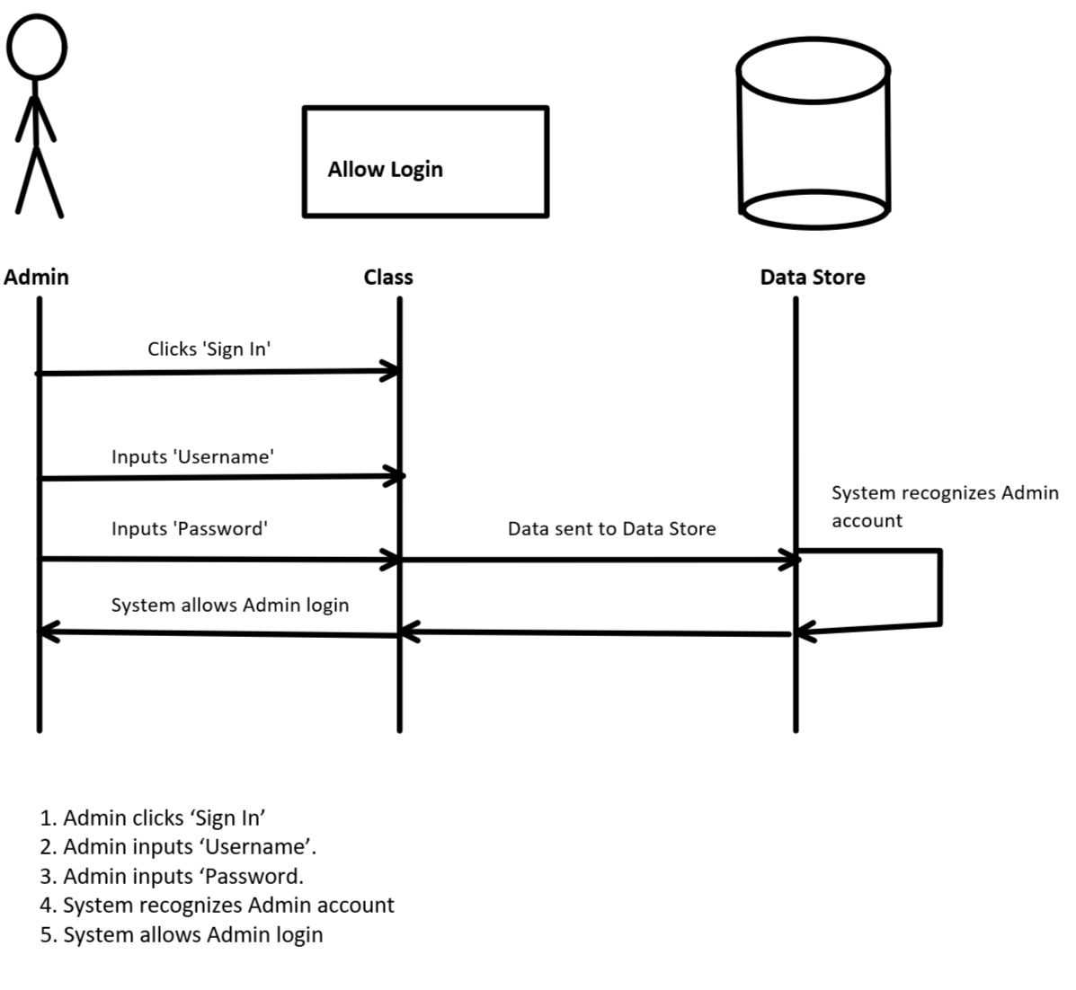

Use-Case Name: CreateContactInformation

ID: UC23

Importance: High

Primary Actor: Admin

Preconditions:
1. Admin is logged in
2. Admin goes to ‘Contact’ tab
Flow of Events:
1. System displays boxes for Organization information to be filled in
2. Admin inputs ‘Company Name’.
3. Admin inputs ‘Address’.
4. Admin inputs ‘Email Address’.
5. Admin inputs ‘Phone Number’.
6. Admin clicks Submit.
Postconditions: Company Contact information is created on website.

Create Contact Information Prototype
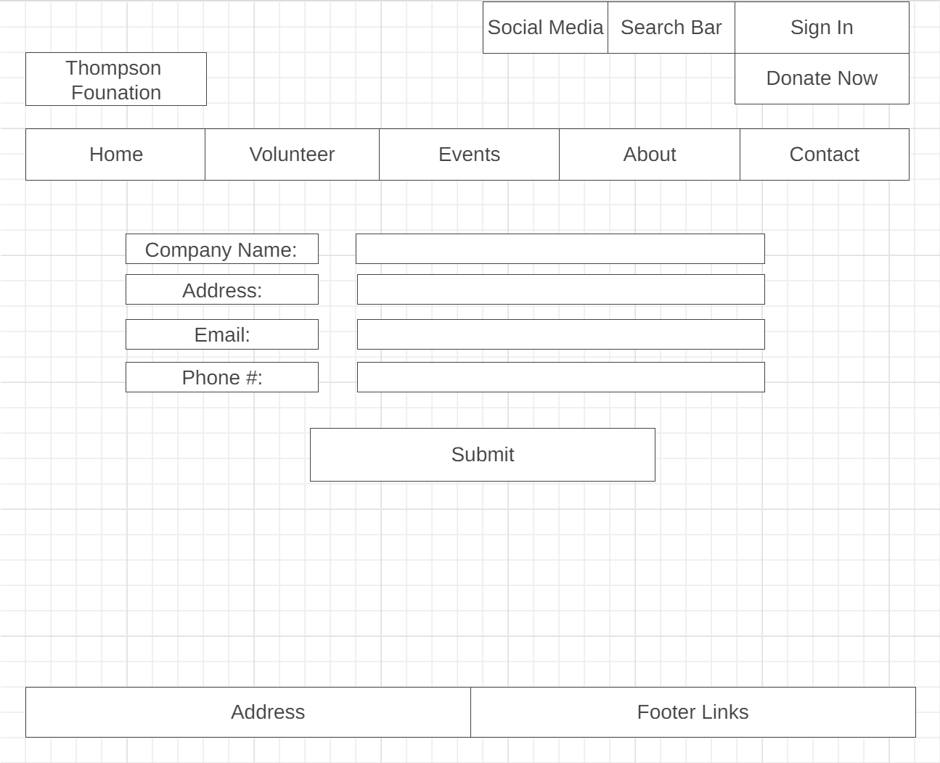

Contact Information (Create)
This diagram shows the attributes and methods that are involved with class ‘Contact Information’. Attributes are listed in the second box and constitute ‘Admin data’. Methods are listed in the third box and include actions the admin takes to complete the main flow.

Create Contact Information
- Company Name
- Address
- Email
- Phone Number
Inputs
Clicks

Create Contact Information Sequence Diagram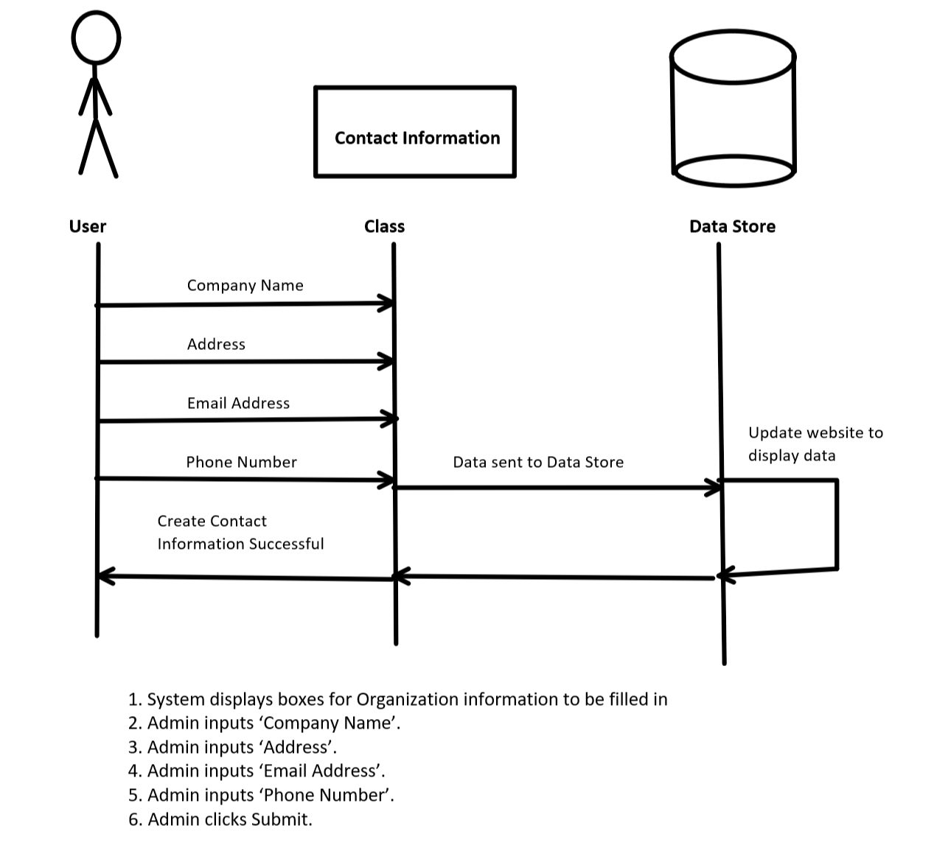

Use-Case Name: EditContactInformation

ID: UC24

Importance: High

Primary Actor: Admin

Preconditions:
1. Admin is logged in
2. Admin goes to ‘Contact’ tab
Flow of Events:
1. System displays boxes for current Organization information
2. Admin inputs ‘Company Name’.
3. Admin inputs ‘Address’.
4. Admin inputs ‘Email Address’.
5. Admin inputs ‘Phone Number’.
6. Admin clicks Submit.
Postconditions: Company Contact information is edited on website.

Create Contact Information Prototype

Contact Information (Edit)
This diagram shows the attributes and methods that are involved with class ‘Contact Information’. Attributes are listed in the second box and constitute ‘Admin data’. Methods are listed in the third box and include actions the admin takes to complete the main flow.

Edit Contact Information
- Company Name
- Address
- Email
- Phone Number
Inputs
Clicks

Edit Contact Information Sequence Diagram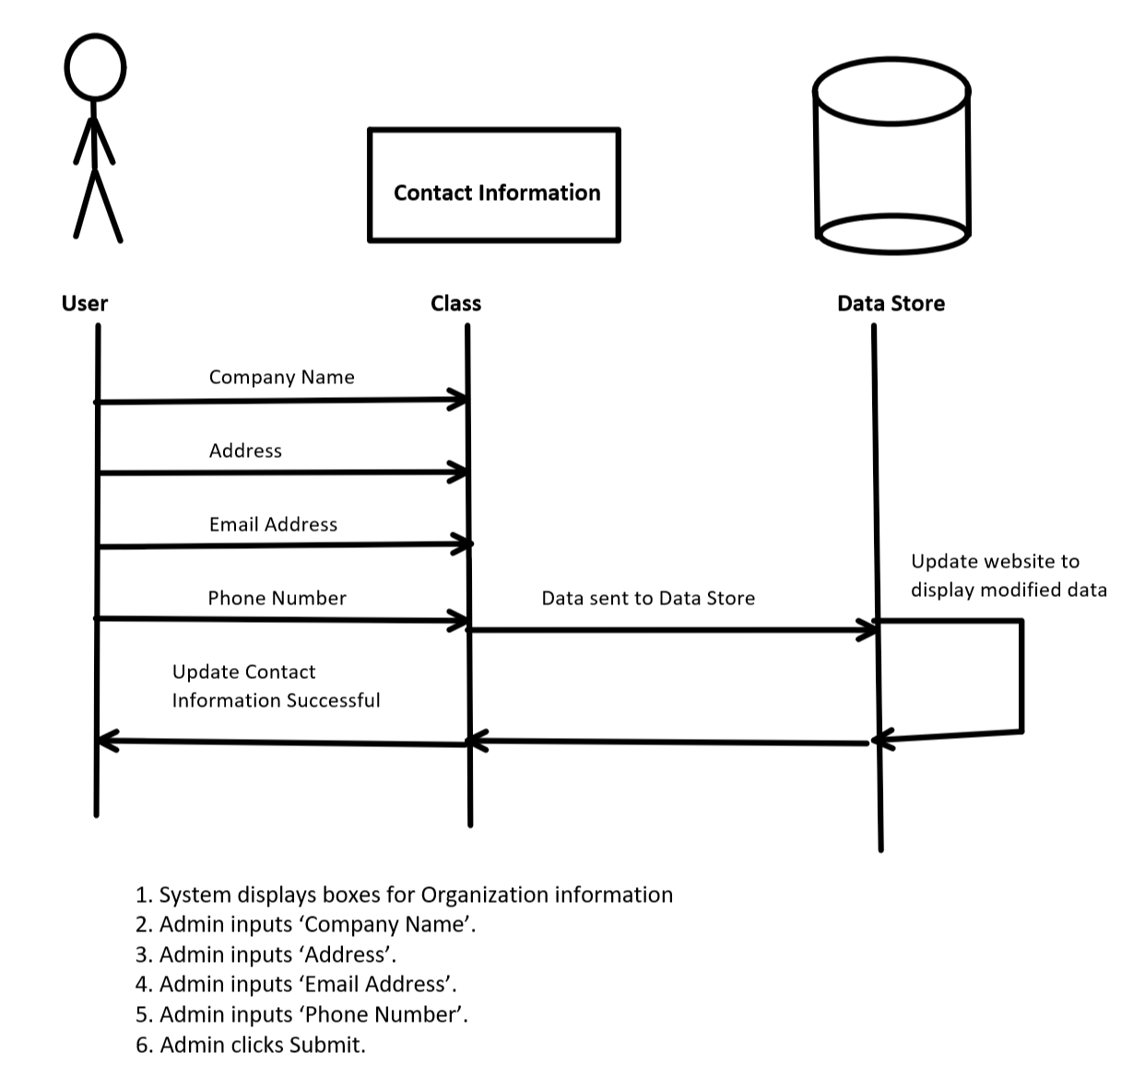

Use-Case Name: DeleteContactInformation

ID: UC25

Importance: High

Primary Actor: Admin

Preconditions:
1. Admin is logged in
2. Admin goes to ‘Contact’ tab
Flow of Events:
1. System displays boxes for current Organization information
2. Admin clicks ‘Delete Organization Information’
3. System displays confirmation box.
4. Admin clicks ‘Confirm’ on pop-up text box.

Postconditions: Company Contact information is deleted on website.

Delete Contact Information Prototype
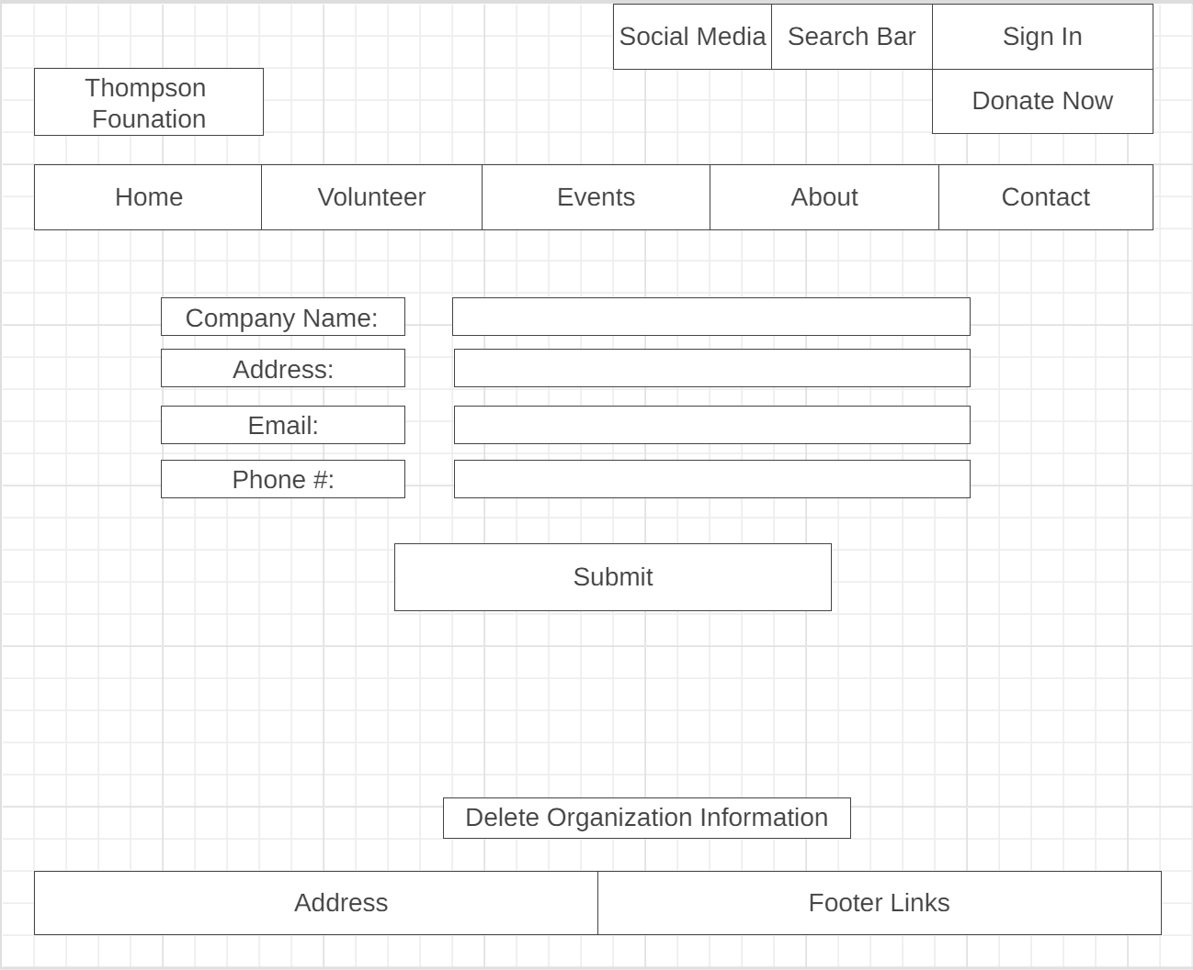

Contact Information (Delete)
This diagram shows the attributes and methods that are involved with class ‘Contact Information’. Attributes are listed in the second box and constitute ‘Admin data’. Methods are listed in the third box and include actions the admin takes to complete the main flow.

Delete Contact Information
- Company Name
- Address
- Email
- Phone Number
Clicks

Delete Contact Information Sequence Diagram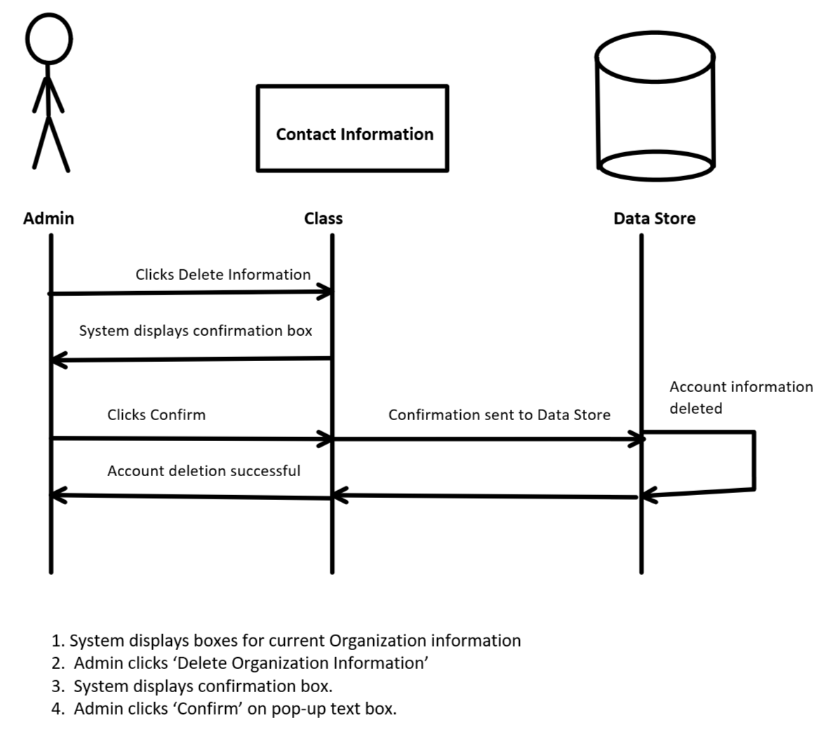

Use-Case Name: AddPayment

ID: UC26

Importance: High

Primary Actor: User

Preconditions:
1. User is on Donate page
Flow of Events:
1. System displays boxes for user to fill out
2. User inputs ‘First Name’.
3. User inputs ‘Last Name’.
4. User inputs ‘Credit Card Number’
5. User inputs ‘PIN Number’
6. User inputs ‘Billing Address’
7. User selects ‘One Time Payment’ or ‘Monthly Payment’
8. User clicks Submit
Postconditions: User Donation is confirmed through Bank and System.

AddPayment Prototype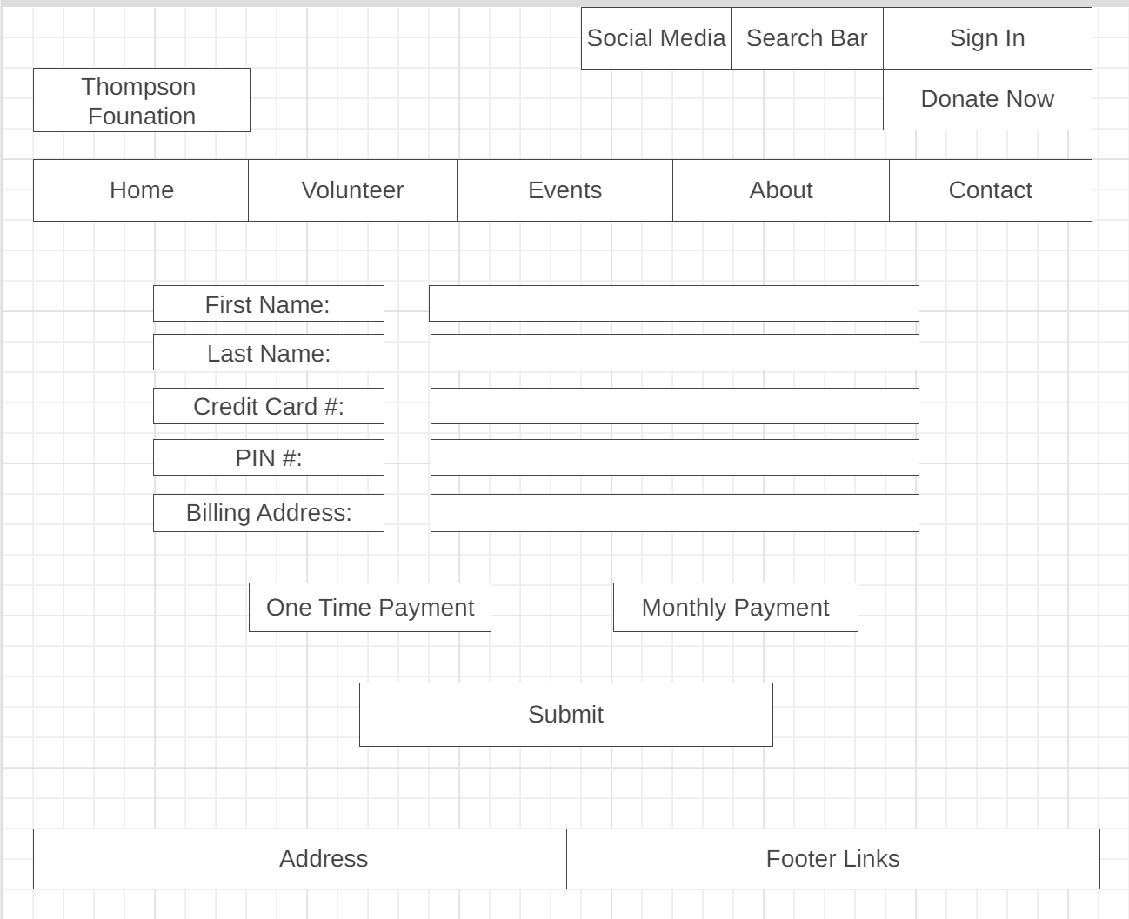

Payment Class Diagram (Add)
This diagram shows the attributes and methods that are involved with class ‘Payment. Attributes are listed in the second box and constitute ‘Payment data’. Methods are listed in the third box and include actions the user takes to complete the main flow.

Payment
- First Name
- Last Name
- Credit Card Number
- PIN
- Billing Address
Clicks
Inputs

AddPayment Sequence Diagram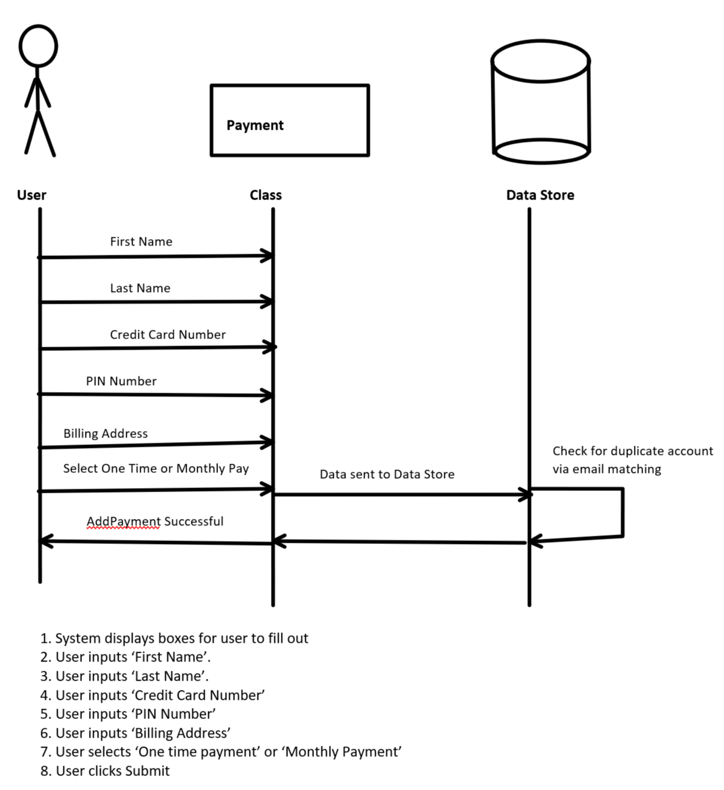

Use-Case Name: EditPayment

ID: UC27

Importance: High

Primary Actor: User

Preconditions:
1. User is logged in
2. User is on Donate page
Flow of Events:
1. System displays boxes for user to fill out
2. User inputs ‘First Name’.
3. User inputs ‘Last Name’.
4. User inputs ‘Credit Card Number’
5. User inputs ‘PIN Number’
6. User inputs ‘Billing Address’
7. User selects ‘One time payment’ or ‘Monthly Payment’
8. User clicks Submit
Postconditions: User Donation information is confirmed to have changed through Bank and System.

Edit Payment Prototype

Payment Class Diagram (Edit)
This diagram shows the attributes and methods that are involved with class ‘Payment. Attributes are listed in the second box and constitute ‘Payment data’. Methods are listed in the third box and include actions the user takes to complete the main flow.

Payment
- First Name
- Last Name
- Credit Card Number
- PIN
- Billing Address
Clicks
Inputs

EditPayment Sequence Diagram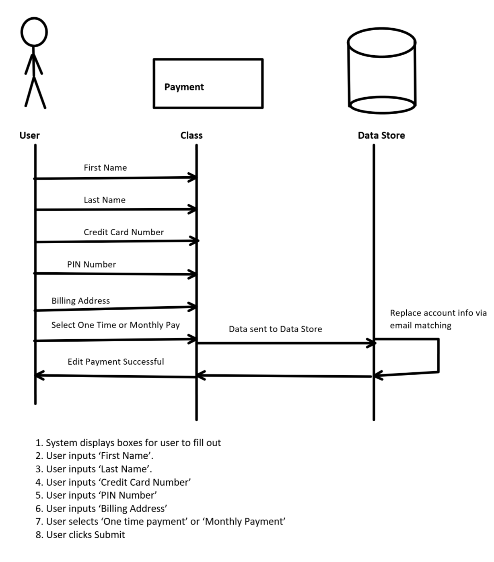

UC28. DeletePayments
- Actor: User/Admin
- Description: For any reason a payment must be deleted, the administrator and user will have access to delete the payments.
UC29. CreateTestimonials
- Actor: User/Admin
- Description: Users will be able to write a testimonial that can be included in the testimonial page on the webpage while administrators can choose to add them onto the page.
UC30. EditTestimonials
- Actor: User/Admin
- Description: Any edits with the testimonies will be able to do from the administrators or the user.
UC31. DeleteTestimonials
- Actor: Admin
- Description: For any reason the testimonies need to be deleted, the admin will be able to delete them from the website.
UC32. CreateResources
- Actor: Admin
- Description: Admin will be able to add resources on the webpage for the juveniles/parents to view and access.
UC33. EditResources
- Actor: Admin
- Description: Admin will have access to edit any of the resources they place on the resources page.
UC34. DeleteResources
- Actor: Admin
- Description: Admin can delete any of the resources they added onto the webpage.
UC35. AddNews
- Actor: Admin
- Description: Admins will create and send out newsletters to volunteers and non-members.
UC36. EditNewsletter
- Actor: Admin
- Description: Admin will be able to edit the newsletters on the webpage.

Use Case Diagrams

User or admin deletes payment (28)
This diagram shows who can delete a payment in our system. Admins and users can delete payments that already exist within our system. The user may only delete payments they have made, while the admin may delete any payment.
User
Admin
Delete payments

User or admin adds testimonial (29)
User or admin edits testimonial (30)
Admin deletes testimonials (31)
This diagram shows who can modify testimonials. Users and admins may both create and alter testimonials in our system, but only admins can remove a testimonial from our website.

Admin
User
Delete testimonial
Edit testimonial
Create testimonial

Admin creates resource (32)
Admin edits resource (33)
Admin deletes resource (34)
This diagram shows who can modify resources. Admins are the only users that have access to resources shown on our website. Users do not need to create, edit, or delete resources so their access is restricted.
Admin
Delete resource
Edit resource
Create resource

Admin adds news (35)
Admin edits newsletter (36)
This diagram shows who can modify news and newsletters on our website. Only admins have access to adding and editing news/newsletters on the website. The website’s news is meant to be added by the admin and sent to the website users.
Admin
Edit newsletter
Create newsletter

Use Case Prototypes
28. Delete Payment
Once logged in and on the Donate page (highlighted tab), the user may view their payment history. They may see their information, amount paid, last 4 digits of the card used, and the option to delete the payment.
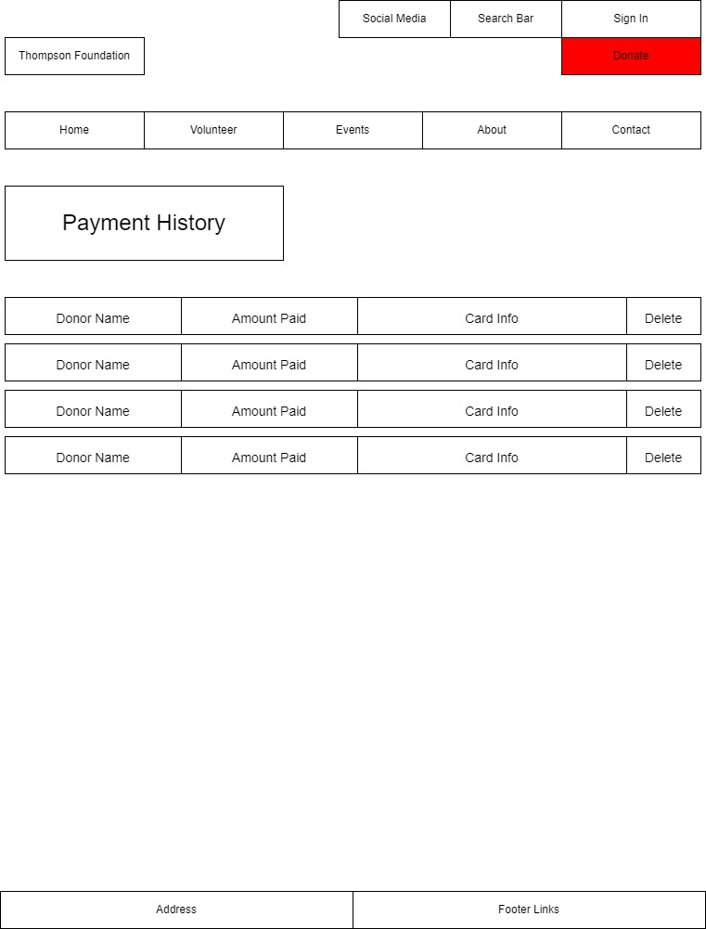

29. Add Testimonial
30. Edit Testimonial
31. Delete Testimonial
Once logged in and on the About page (highlighted tab), the user and admin will see a list of testimonials from members of the organization. A “+” sign is in the top right which allows the user or admin to add a new testimonial. Next to the quote, an edit (pencil) and delete (X) button are shown to allow the user or admin to edit or delete the testimonials.
NOTE: The edit and delete buttons will show on all testimonials for the admin. For the user, only the testimonials created by the user will have the edit and delete option.
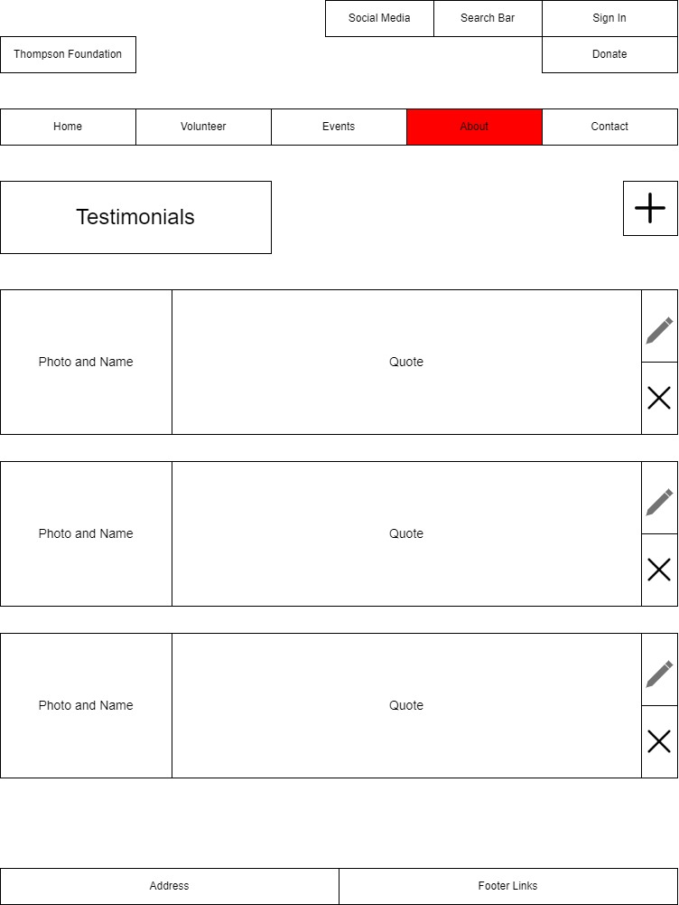
32. Create Resource
33. Edit Resource
34. Delete Resource
Once logged in and on the About page (highlighted tab), the admin will be able to create, edit, and delete resources on the website. A “+” sign is in the top right of the page which allows the admin to add a resource tab to the Resource page. In the top right corner of each resource tab are two small boxes. The left box is the edit selection marked with a pencil. The right box is a delete box marked with an “X”.
NOTE: The user will see the same page as the admin (as shown below). However, the user will not see the add, edit, and delete buttons.
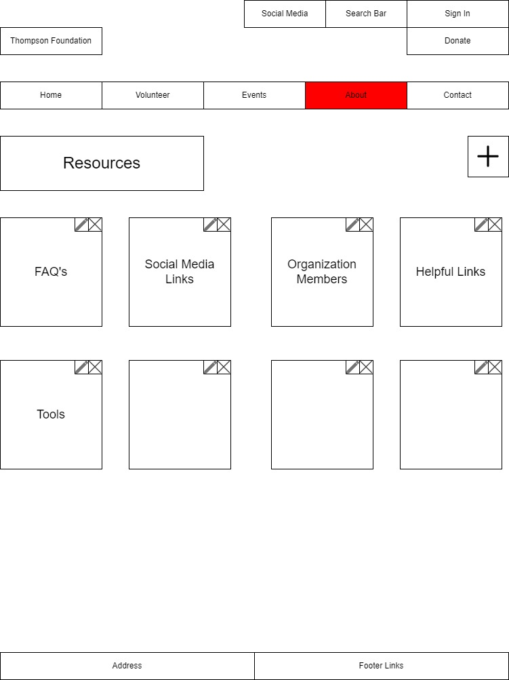
35. Create Newsletter
36. Edit Newsletter
Once logged in and on the About page (highlighted tab), the admin can create new newsletters or edit existing newsletters on the website. The create button is the create (+) button below the contact page, and the edit (pencil) button is in the top right of each newsletter tab. The admins are the only ones allowed to create and edit newsletters on the website. The user will see the same page (as shown below). However, the create and edit buttons will be hidden.
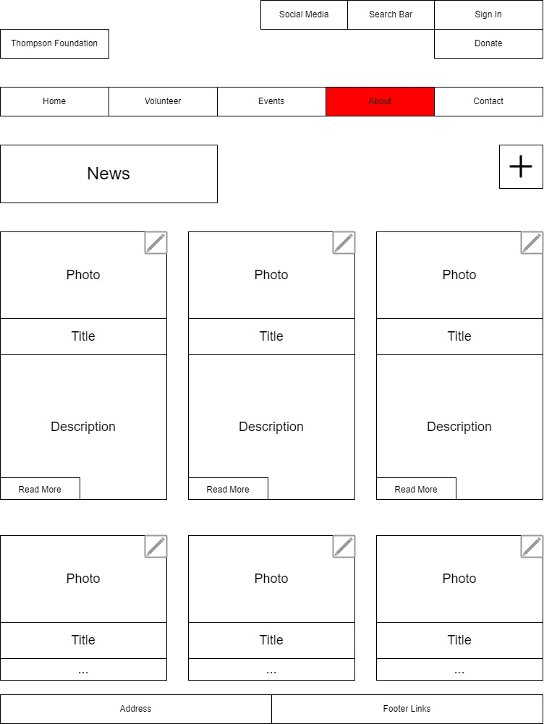

Class Diagrams
This Class Diagram depicts the relationship between all classes mentioned in the Use Case Main Flows of each Use Case. The top-most portion of each box is the name of the class. The middle portion of each box states the attributes, or parts, of the class. Finally, the bottom portion states the methods, or actions, of each class.

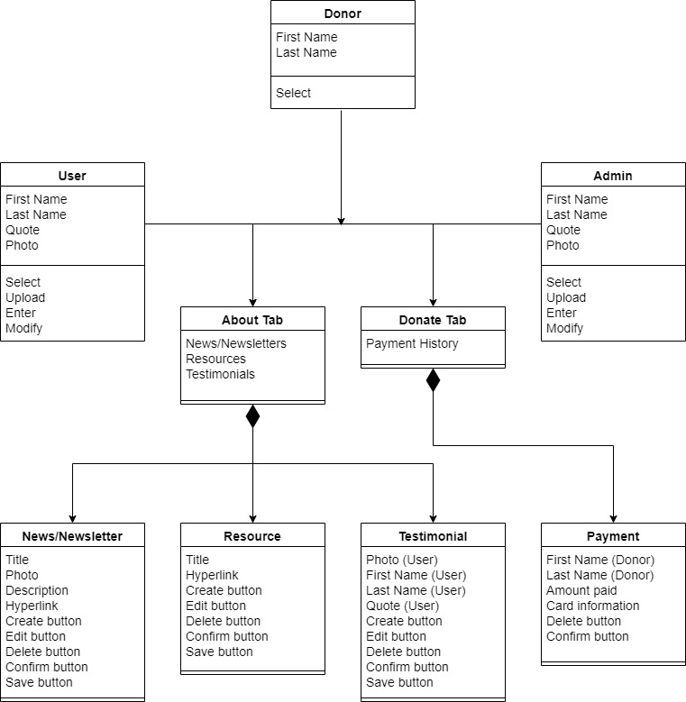

Sequence Diagram
Precondition: User is already logged into the system and is at the Home page.
NOTE: The term “User” in the main flow is synonymous for both users and admins because admins are also users of the system. When “Admin” is displayed, users do not have access to this action.

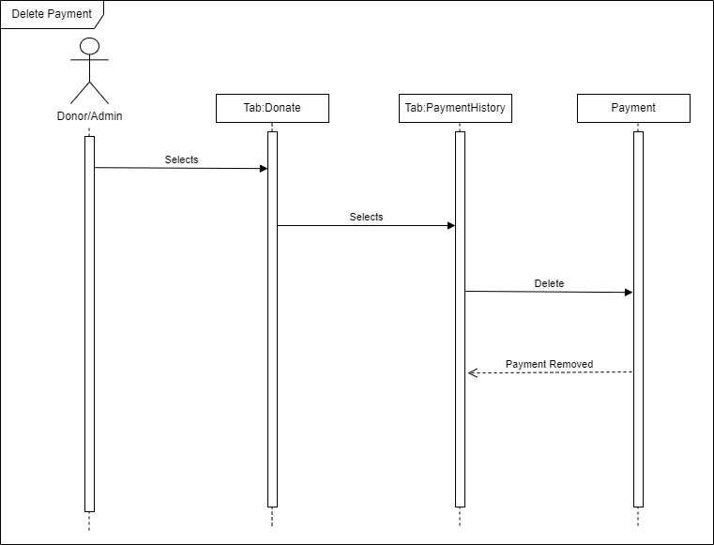
Delete Payment
Main Flow:
- Donor/Admin selects Donate tab.
- Donor/Admin selects Payment History tab.
- Donor/Admin selects Delete button.
- Donor/Admin selects Confirm button.

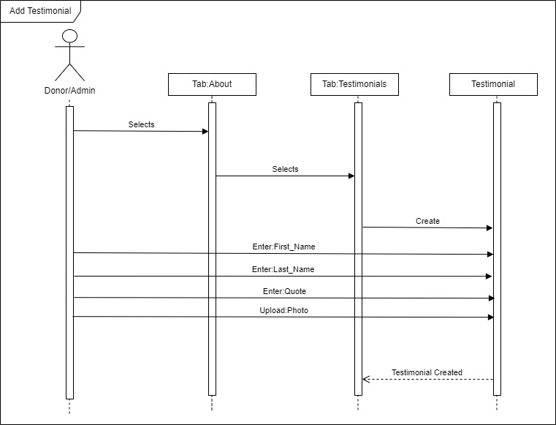
Add Testimonial
Main Flow:
- User selects About tab.
- User selects Testimonials tab.
- User selects Create (+) button.
- User uploads Photo.
- User enters First Name.
- User enters Last Name.
- User enters Quote.
- User selects Confirm button.

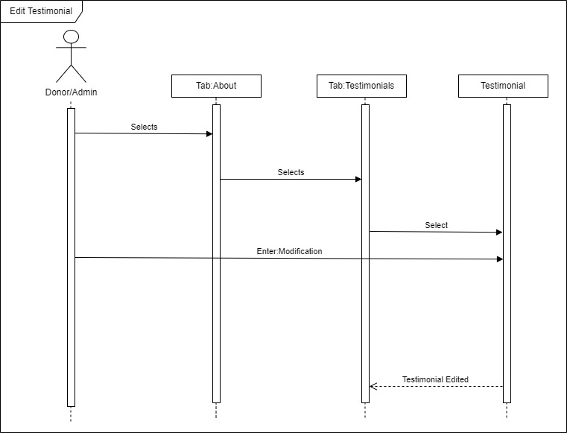
Edit Testimonial
Main Flow:
- User selects About tab.
- User selects Testimonials tab.
- User selects Edit (pencil) button.
- User modifies Testimonial.
- User selects Save button.

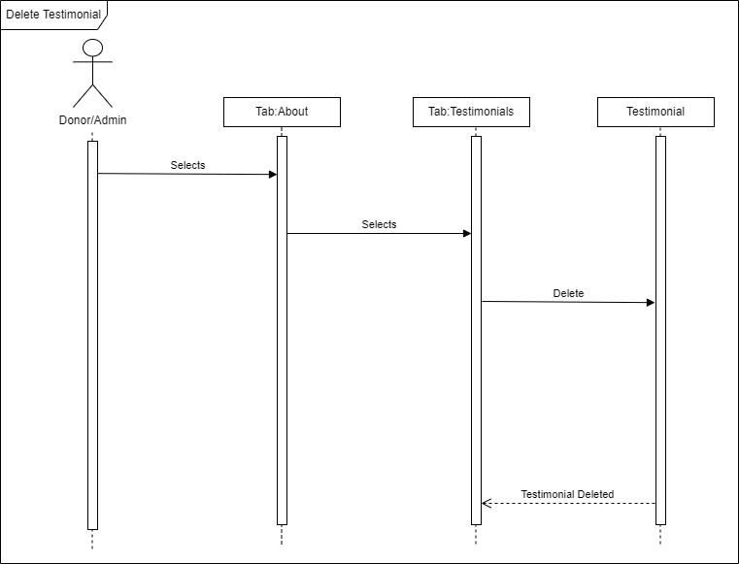
Delete Testimonial
Main Flow:
- Admin selects About tab.
- Admin selects Testimonials tab.
- Admin selects Delete (X) button.
- Admin selects Confirm button.

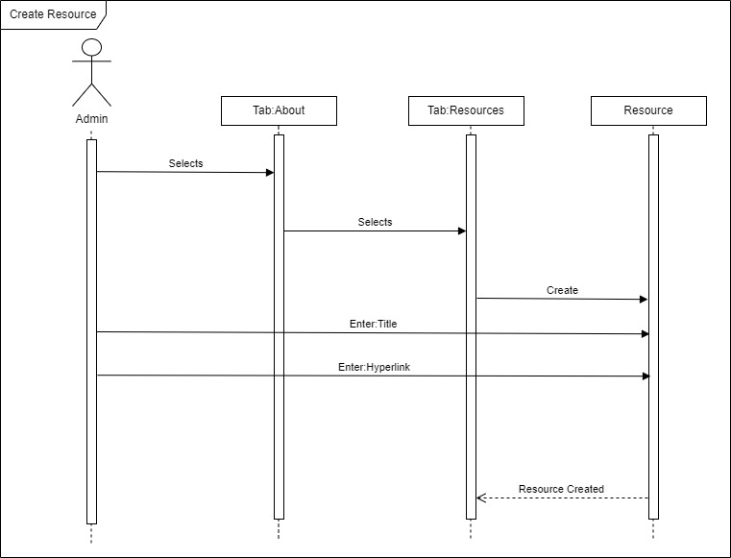
Create Resource
Main Flow:
- Admin selects About tab.
- Admin selects Resources tab.
- Admin selects Create (+) button.
- Admin enters Resource Title.
- Admin enters Resource Page Hyperlink.
- Admin selects Confirm button.

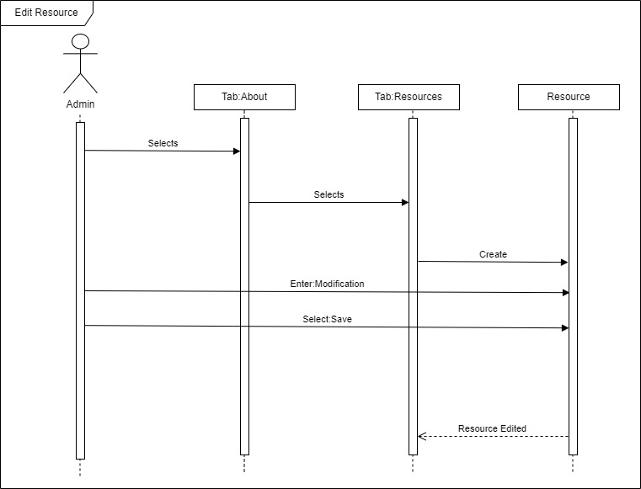
Edit Resource
Main Flow:
- Admin selects About tab.
- Admin selects Resources tab.
- Admin selects Edit (pencil) button.
- Admin modifies Resource.
- Admin selects Save button.

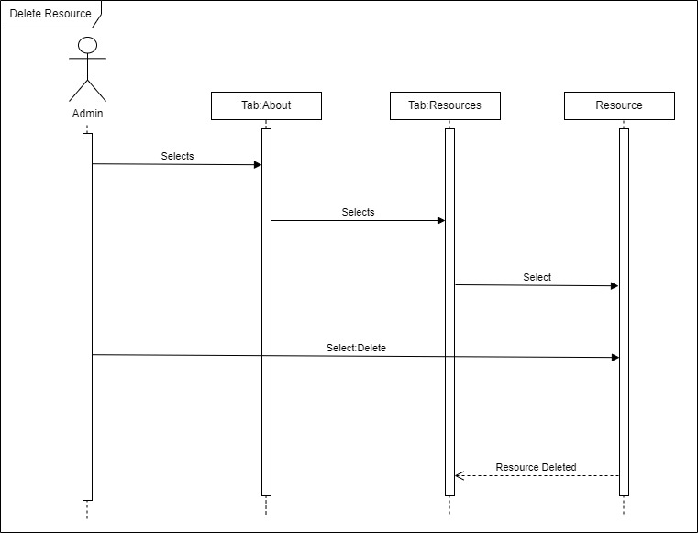
Delete Resource
Main Flow:
- Admin selects About tab.
- Admin selects Resources tab.
- Admin selects Delete (X) button.
- Admin selects Confirm button.

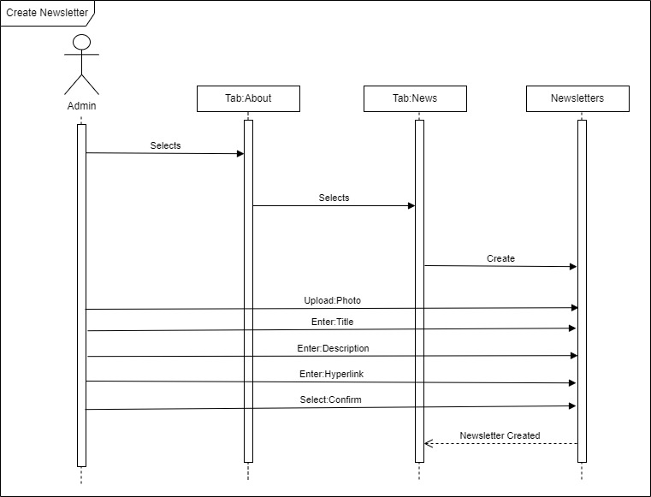
Create Newsletter
Main Flow:
- Admin selects About tab.
- Admin selects News tab.
- Admin selects Create (+) button.
- Admin uploads Photo.
- Admin enters Title.
- Admin enters Description.
- Admin enters Article Hyperlink.
- Admin selects Confirm button.

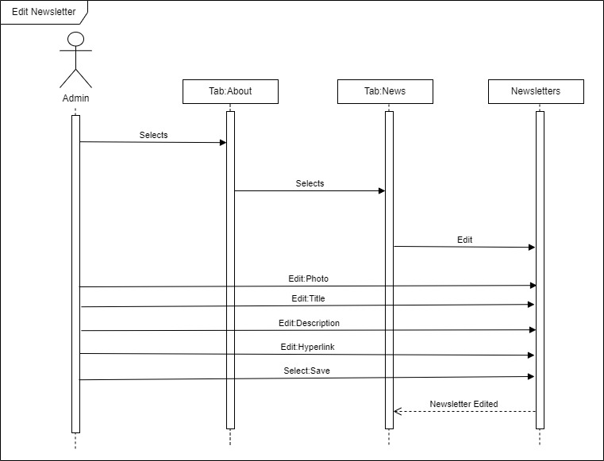
Edit Newsletter
Main Flow:
- Admin selects About tab.
- Admin selects News tab.
- Admin selects Edit (pencil) button.
- Admin modifies News/Newsletter.
- Admin selects Save button.

USE CASE: Delete News
ID: UC37
ACTOR: Admin
IMPORTANCE: Low
PRECONDITIONS: Actor must be logged in; Actor must have admin access
FLOW OF IMPORATNACE: 1. Actor logs into website site 2. actor navigates to the news section of the home page 2. actor selects what news needs to be deleted 3. Actor clicks deletes 4. Actor Confirms deletion
POSTCONDITIONS: The news is deleted

USE CASE DIAGRAM FOR USE CASE 37

ADMIN
Delete News

USE CASE: Add Subscription
ID: UC38
ACTOR: User
IMPORTANCE: High
PRECONDITIONS: User must be logged in
FLOW OF IMPORATNACE: 1. Actor logs into website site 2. Actor navigates to the donate tab2. actor selects subscription 3. Actor enters subscription information 4. Actor Confirms subscription
POSTCONDITIONS: The subscription is created
USE CASE: Edit Subscription
ID: UC39
ACTOR: User
IMPORTANCE: High
PRECONDITIONS: User must be logged in
FLOW OF IMPORATNACE: 1. Actor logs into website site 2. Actor navigates to the subscription information tab 3. actor selects subscription 3. Actor updates subscription information 4. Actor Confirms subscription update
POSTCONDITIONS: The subscription is updated
USE CASE: Delete Subscription
ID: UC40
ACTOR: User
IMPORTANCE: High
PRECONDITIONS: User must be logged in
FLOW OF IMPORATNACE: 1. Actor logs into website site 2. Actor navigates to the subscription information tab 3. actor selects subscription 3. Actor selects delete subscription information 4. Actor Confirms subscription deletion
POSTCONDITIONS: The subscription is deleted

USE CASE DIAGRAM FOR USE CASE 39-40
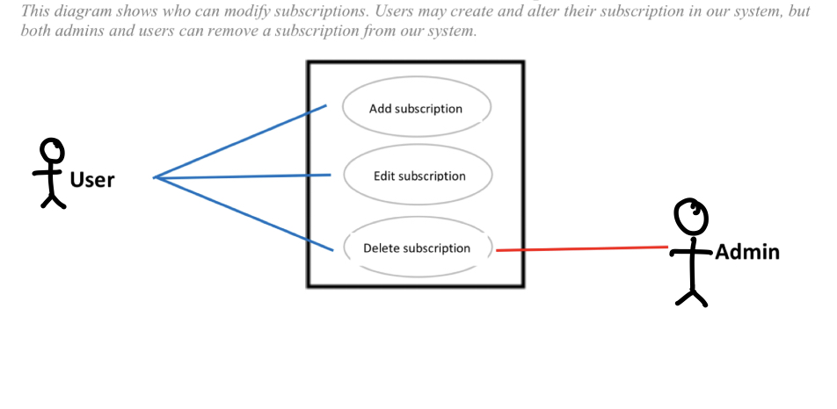

USE CASE: Create Attendee
ID: UC41
ACTOR: User
IMPORTANCE: High
PRECONDITIONS: User must be logged in
FLOW OF IMPORATNACE: 1. Actor logs into website site 2. Actor navigates to the events page3. actor selects an event 3. Actor clicks sign me up! 4. Actor Confirms to sign up
POSTCONDITIONS: the attendee was added to an event

USE CASE: Edit Attendee
ID: UC42
ACTOR: User
IMPORTANCE: High
PRECONDITIONS: User must be logged in
FLOW OF IMPORATNACE: 1. Actor logs into website site 2. Actor navigates to my events tab in Account Info 3. actor selects an event 3. Actor edits needed information 4. Actor Confirms the edit
POSTCONDITIONS: the attendee was edited

USE CASE: Delete Attendee
ID: UC43
ACTOR: User
IMPORTANCE: High
PRECONDITIONS: User must be logged in
FLOW OF IMPORATNACE: 1. Actor logs into website site 2. Actor navigates to my events tab in Account Info 3. actor selects an event 3. Actor clicks delete4. Actor Confirms
POSTCONDITIONS: the attendee was deleted

USE CASE DIAGRAM FOR 41-43

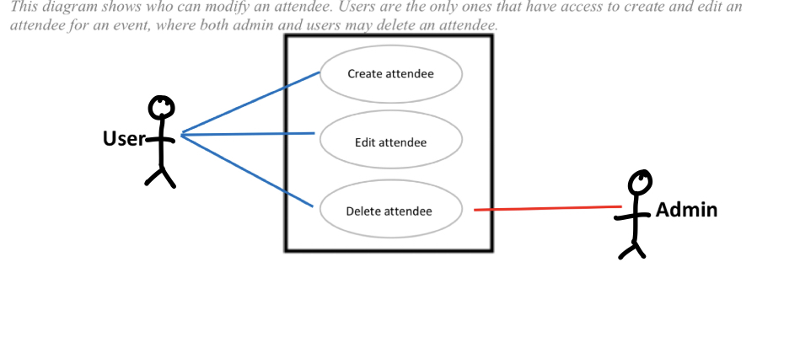

USE CASE: Create Backup
ID: UC44
ACTOR: Admin
IMPORTANCE: High
PRECONDITIONS: User must be logged in
FLOW OF IMPORATNACE: 1. Actor logs into website site 2. Actor navigates to backups in admin access 3. actor selects create backup. Actor Confirms
POSTCONDITIONS: a backup was created

USE CASE: Restore Backup
ID: UC45
ACTOR: Admin
IMPORTANCE: High
PRECONDITIONS: User must be logged in
FLOW OF IMPORATNACE: 1. Actor logs into website site 2. Actor navigates to backups in admin access 3. actor selects restore backup. 4.actor selects date 5 Actor Confirms
POSTCONDITIONS: a backup was restored

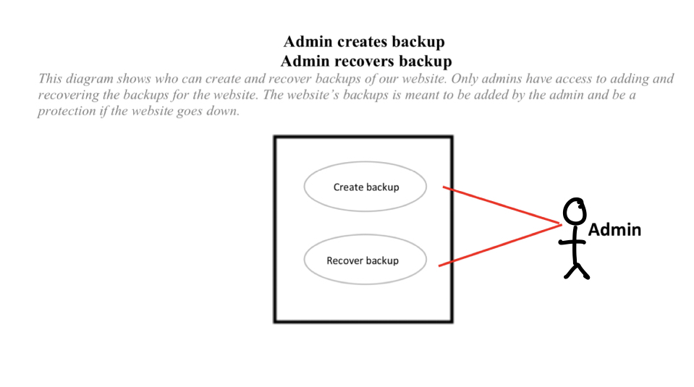

CLASS DIAGRAMS
This will show the attributes and methods for each class.
NEWS CLASS DIAGRAM

CLASS
News

Attributes
Links
Articles
Pictures
Logos
Events
Methods
Click

Attendee Class Diagram
CLASS
Attendee

Attributes
Events
Event Date
Time
Name

Methods
Click
Input

SUBSCRIPTION CLASS DIAGRAM
CLASS
Subscription

Attributes
Credit Card Number
CCV
Name on CC
EXP Date
Amount
Frequency
Delete

Methods
Click
Input

Backup Class Diagram
CLASS
Backup

Attributes
Create Backup
Recover Backup
Date
Submit

Methods
Click
Input

Sequence Diagram For Delete News

User (Admin) Class (News) Data Storage
Links
Articles
Pictures
Logos
Deleted News information updated
Updated data sent to Data Storage
Events

News Deleted

Steps.
- Admin logs in and navigates to the news section of the home page
- Admin then clicks on the news that is to be deleted
- Deletes the news, and presses confirm
- Data is sent to data storage
- Updates websites, user no longer sees the news

Sequence Diagram For Attendee Class
User (User) Class (Attendee) Data Storage
Events
Event Date
Time
Name
Attendee information updated
Updated data sent to Data Storage
User sees updated information
For Create attendee
- User logs in and navigates to the events page
- User clicks on a date
- User presses sign up now!
- Data is sent to data storage
- Data is sent back showing that the event has a new attendee
For Edit attendee
- User logs in and navigates to the my events page
- User clicks on the event
- User updates information
- Data is sent to data storage
- Data is sent back showing that the event has an edited attendee

For delete attendee
- User logs in and navigates to the my events page
- User clicks on the event
- User clicks delete
- Data is sent to data storage
- Data is sent back showing that the event no longer has that attendee

Sequence Diagram for Subscriptions Class

User (User) Class (Subscription) Third Party Payment Processer
Credit Card Number
CCV
Name on CC
EXP Date
Amount
Frequency
Subscription information saved
Data sent to third party payment processer
Submit
Delete
User sees subscription processed
For create subscription
1.User logs in and navigates to the subscriptions pages
- User enters amount
- User clicks frequency
- User enters Credit card Number
- User Enters CCV
- User enters expiration date
- User enters name on card
- User clicks submit
- Data is sent to 3rd party payment processer
- Data is sent back showing that a new subscription was made
For edit subscription
1.User logs in and navigates to the subscriptions pages
- User updates needed information
- User clicks submit
- Data is sent to 3rd party payment processer
- Data is sent back showing that the subscription was edited
For delete subscription
1.User logs in and navigates to the subscriptions pages
- User clicks the delete radio buton
- User clicks submit
- Data is sent to 3rd party payment processer
- Data is sent back showing that the subscription was deleted

Sequence Diagram For Backup Class
User (Admin) Class (Backup) Data Storage
Create backup
Recover backup
Date
Backup sent to data storage
Submit
Backup information updated

Backup Created or recovered
For create backup
1. User logs in and navigates to the admins backup page
2. User clicks the create backup button
3. User clicks submit
4. Backup created

For recover backup
1. User logs in and navigates to the admins backup page
2. User clicks the recover backup button
3. User selects the date
3. User clicks submit
4. Backup recovered

CreateAttendee Class Prototype
Social Media
Account Info
Thompson Foundation
Home
Volunteer
Events
About
Search Bar
Donate Now

Create
Contact

Attend Event
Event Name:

Date:
Name:

Submit
Delete

Thank You Message

You Might Also Enjoy

Footer Links

Address
EditAttendee Class Prototype
Social Media
Account Info
Thompson Foundation
Home
Volunteer
Events
About
Search Bar
Donate Now

Create
Contact

Attend Event
Event Name:

Date:
Name:

Submit
Delete

Thank You Message

You Might Also Enjoy

Footer Links
Address

DeleteAttendee Class Prototype
Social Media
Account Info
Thompson Foundation
Home
Volunteer
Events
About
Search Bar
Donate Now

Create
Contact

Attend Event
Event Name:

Date:
Name:

Submit
Delete

Thank You Message

You Might Also Enjoy

Footer Links
Address

CreateSubscription Class Prototype
Social Media
Account Info
Thompson Foundation
Home
Volunteer
Events
About
Search Bar
Donate Now

Create
Contact

Subscription
Amount:
Frequency
Credit Card Numberer
CCV

EXP DATE
Name On Card
Submit
Delete

Thank You Message

Footer Links
Address

EditSubscription Class Prototype
Social Media
Account Info
Thompson Foundation
Home
Volunteer
Events
About
Search Bar
Donate Now

Create
Contact

Subscription
Amount:
Frequency
Credit Card Numberer
CCV

EXP DATE
Name On Card
Submit
Delete

Thank You Message

Footer Links
Address

DeleteSubscription Class Prototype
Social Media
Account Info
Thompson Foundation
Home
Volunteer
Events
About
Search Bar
Donate Now

Create
Contact

Subscription
Amount:
Frequency
Credit Card Numberer
CCV

EXP DATE
Name On Card
Submit
Delete

Thank You Message

Footer Links
Address

Create Backup Prototype
Social Media
Account Info
Thompson Foundation
Home
Volunteer
Events
About
Search Bar
Donate Now

Create
Contact

Backup

Create backup
Recover backup

Date (If recovering)

Submit

To Do

Footer Links
Address

Recover Backup Prototype
Social Media
Account Info
Thompson Foundation
Home
Volunteer
Events
About
Search Bar
Donate Now

Create
Contact

Backup

Create backup
Recover backup

Date (If recovering)

Submit

To Do

Footer Links
Address

DeleteNews Class Prototype
Social Media
Account Info
Thompson Foundation
Home
Volunteer
Events
About
Search Bar
Donate Now

Create
Contact

News
Links
Articles
Pictures
Logos
Events

Delete

News Article

Footer Links
Address

USE CASE: CreateDonorList
ID: 046
ACTOR: Admin
IMPORTANCE: High
PRECONDITIONS: Admin must be logged in
FLOW OF IMPORTANACE: 1. Actor logs into website 2. Actor navigates to the user functions tab 3. actor selects donor list 3. actor creates the donor list
POSTCONDITIONS: The donor list was created

USE CASE: EditDonorList
ID: 047
ACTOR: Admin
IMPORTANCE: High
PRECONDITIONS: Admin must be logged in
FLOW OF IMPORTANACE: 1. Actor logs into website 2. Actor navigates to the user functions tab 3. actor selects donor list 3. actor edits the donor list
POSTCONDITIONS: The donor list was edited

USE CASE: DeleteDonorList
ID: 048
ACTOR: Admin
IMPORTANCE: High
PRECONDITIONS: Admin must be logged in
FLOW OF IMPORTANACE: 1. Actor logs into website 2. Actor navigates to the user functions tab 3. actor selects donor list 3. actor deletes donor list
POSTCONDITIONS: The donor list was deleted

USE CASE: CreateVolunteerList
ID: 049
ACTOR: Admin
IMPORTANCE: High
PRECONDITIONS: Admin must be logged in
FLOW OF IMPORTANACE: 1. Actor logs into website 2. Actor navigates to the user functions tab 3. actor selects volunteer list 3. actor creates the volunteer list
POSTCONDITIONS: The volunteer list was created

USE CASE: EditVolunteerList
ID: 050
ACTOR: Admin
IMPORTANCE: High
PRECONDITIONS: Admin must be logged in
FLOW OF IMPORTANACE: 1. Actor logs into website 2. Actor navigates to the user functions tab 3. actor selects volunteer list 3. actor edits the volunteer list
POSTCONDITIONS: The volunteer list was edited

USE CASE: DeleteVolunteerList
ID: 051
ACTOR: Admin
IMPORTANCE: High
PRECONDITIONS: Admin must be logged in
FLOW OF IMPORATNACE: 1. Actor logs into website 2. Actor navigates to the user functions tab 3. actor selects volunteer list 3. actor deletes the volunteer list
POSTCONDITIONS: The volunteer list was deleted

USE CASE: CreatePhysicalDonation
ID: 052
ACTOR: User
IMPORTANCE: High
PRECONDITIONS:
FLOW OF IMPORTANACE: 1. Actor navigates to the donate page user functions tab 2. actor clicks on make a donation, physical donation 3. actor enters required information
POSTCONDITIONS: The physical donation was created

USE CASE: EditPhysicalDonation
ID: 053
ACTOR: User Admin
IMPORTANCE: High
PRECONDITIONS:
FLOW OF IMPORTANACE: 1. Actor navigates to the donate page user functions tab 2. actor clicks on make a donation, physical donation 3. actor updates required information
POSTCONDITIONS: The physical donation was updated

USE CASE: DeletePhysicalDonation
ID: 054
ACTOR: User, Admin
IMPORTANCE: High
PRECONDITIONS:
FLOW OF IMPORTANACE: 1. Actor navigates to the donate page user functions tab 2. actor clicks on make a donation, physical donation 3. actor deletes information
POSTCONDITIONS: The physical donation was deleted

USE CASE: CreateGrant
ID: 055
ACTOR: Admin
IMPORTANCE: High
PRECONDITIONS: Admin must be logged in
FLOW OF IMPORTANACE: 1. Actor logs into website 2. Actor navigates to the user functions tab 3. actor selects grant tab 3. actor creates the grant
POSTCONDITIONS: The grant was created

USE CASE: EditGrant
ID: 056
ACTOR: Admin
IMPORTANCE: High
PRECONDITIONS: Admin must be logged in
FLOW OF IMPORTANACE: 1. Actor logs into website 2. Actor navigates to the user functions tab 3. actor selects grant tab 3. actor edits the grant information
POSTCONDITIONS: The grant was edited

USE CASE: DeleteGrant
ID: 057
ACTOR: Admin
IMPORTANCE: High
PRECONDITIONS: Admin must be logged in
FLOW OF IMPORTANACE: 1. Actor logs into website 2. Actor navigates to the user functions tab 3. actor selects d 3. actor deletes the grant
POSTCONDITIONS: The grant was deleted

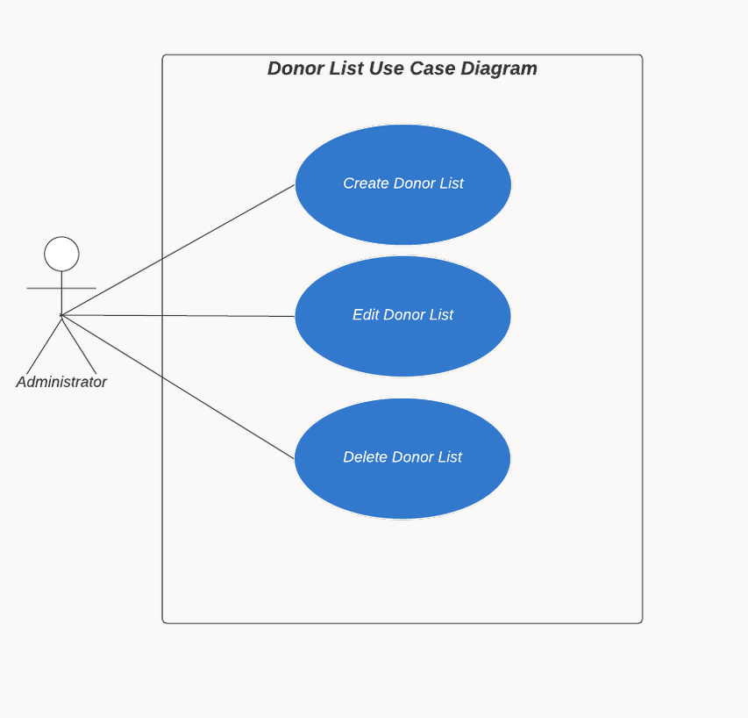

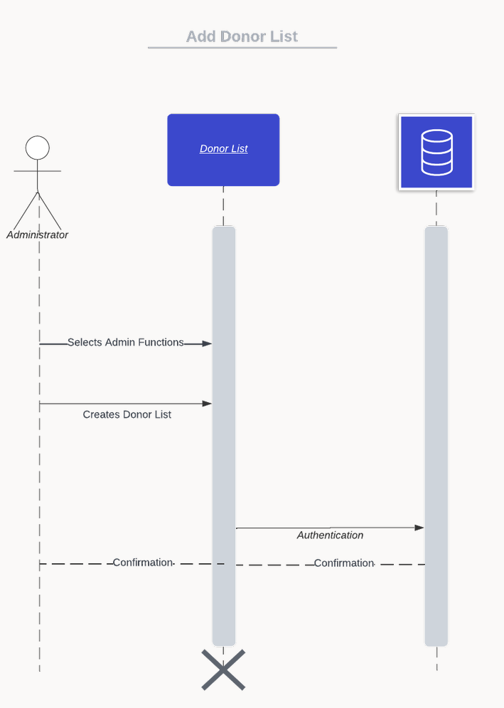

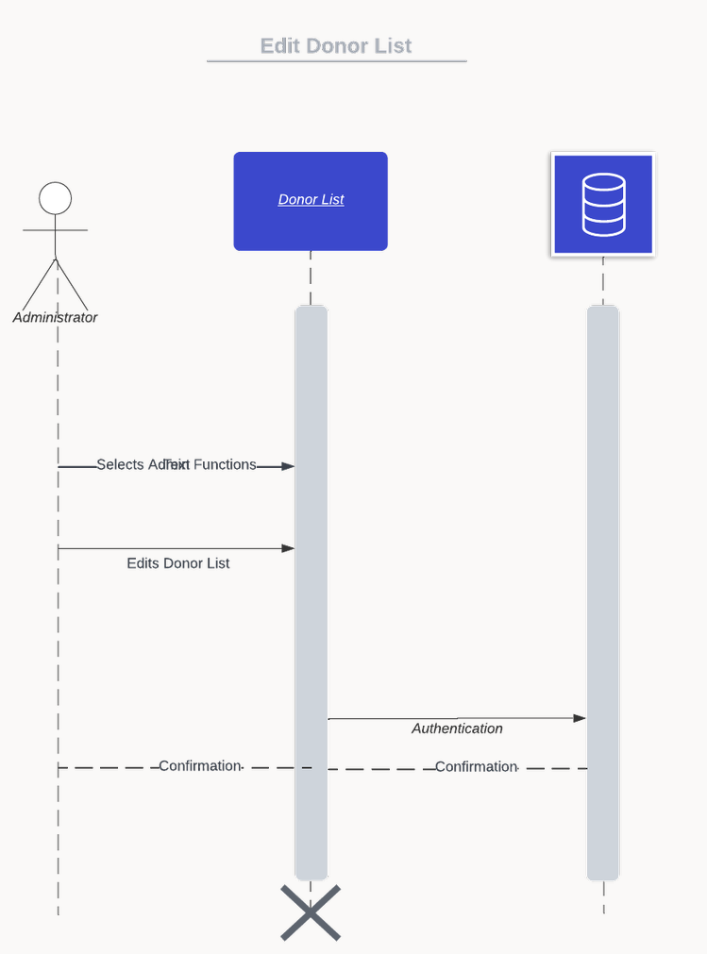

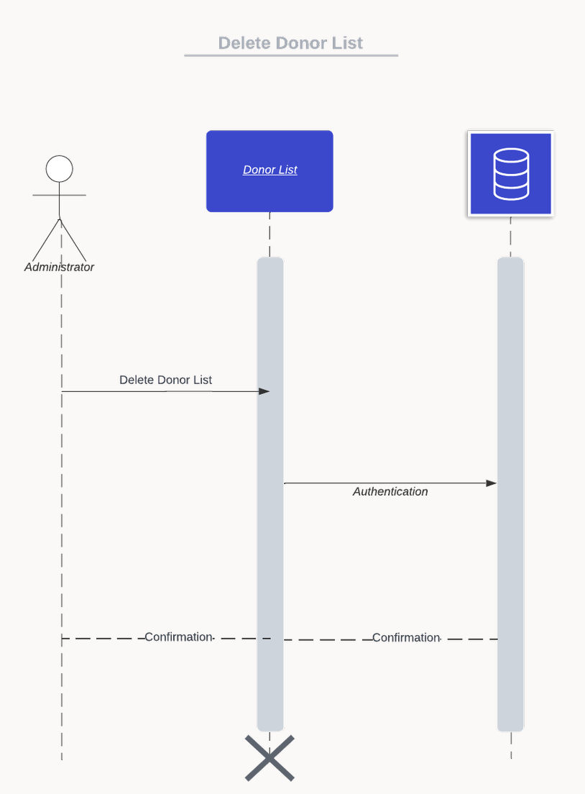

VOLUNTEER LIST DIAGRAMS:
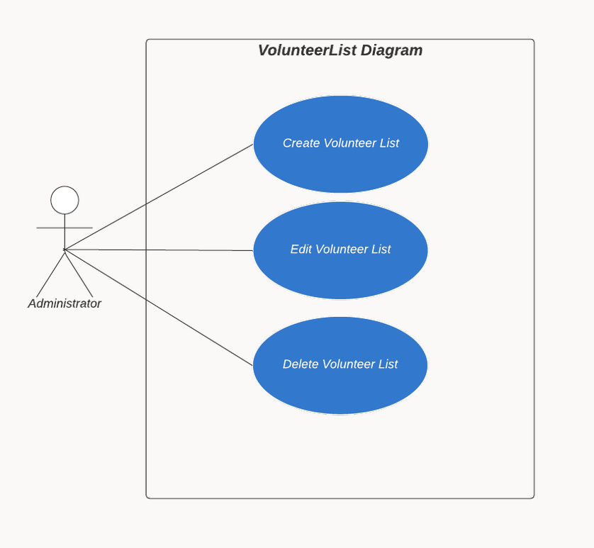
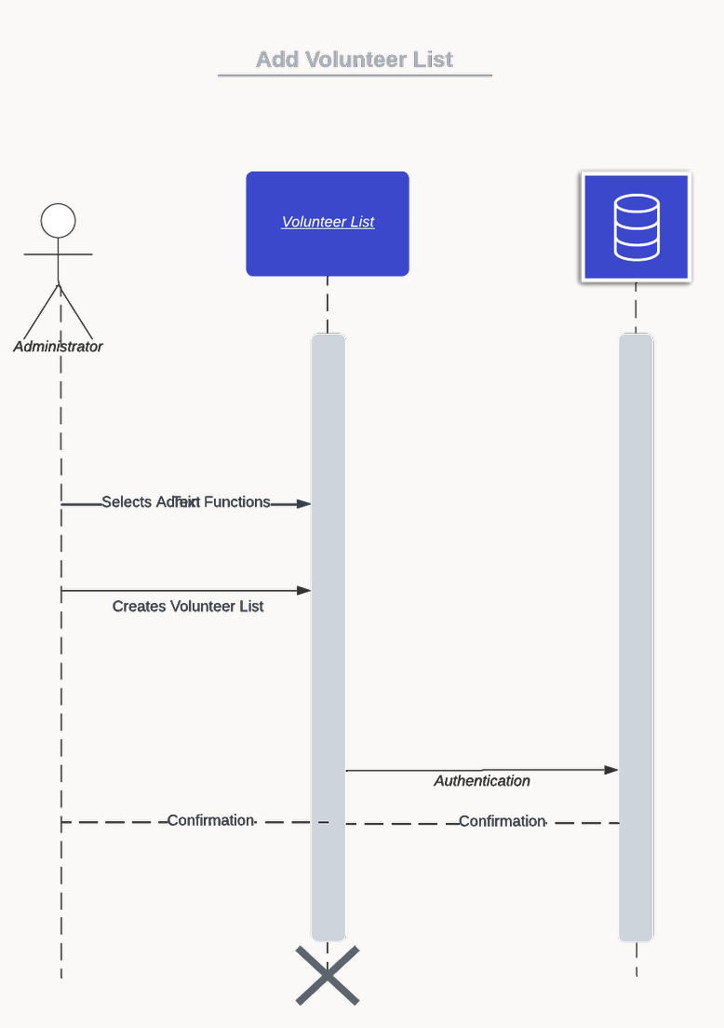

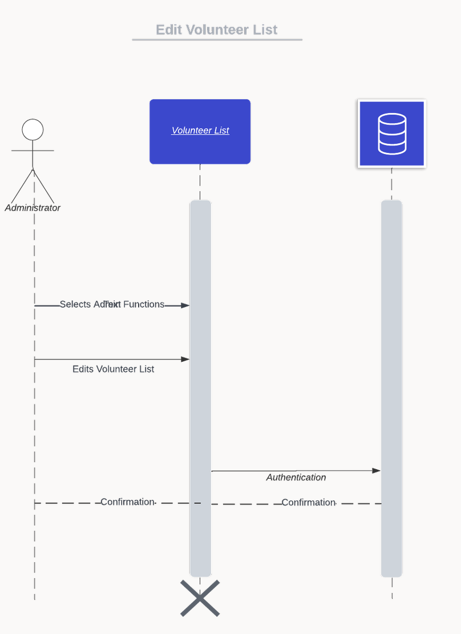

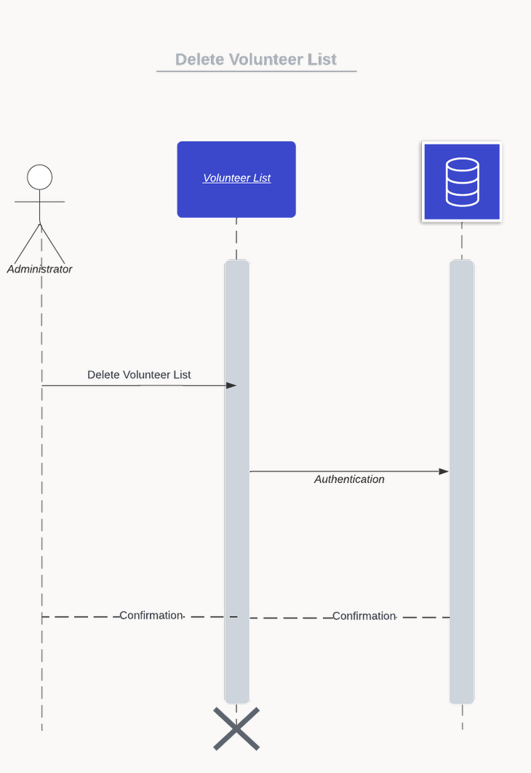

PHYSICAL DONATION DIAGRAMS:
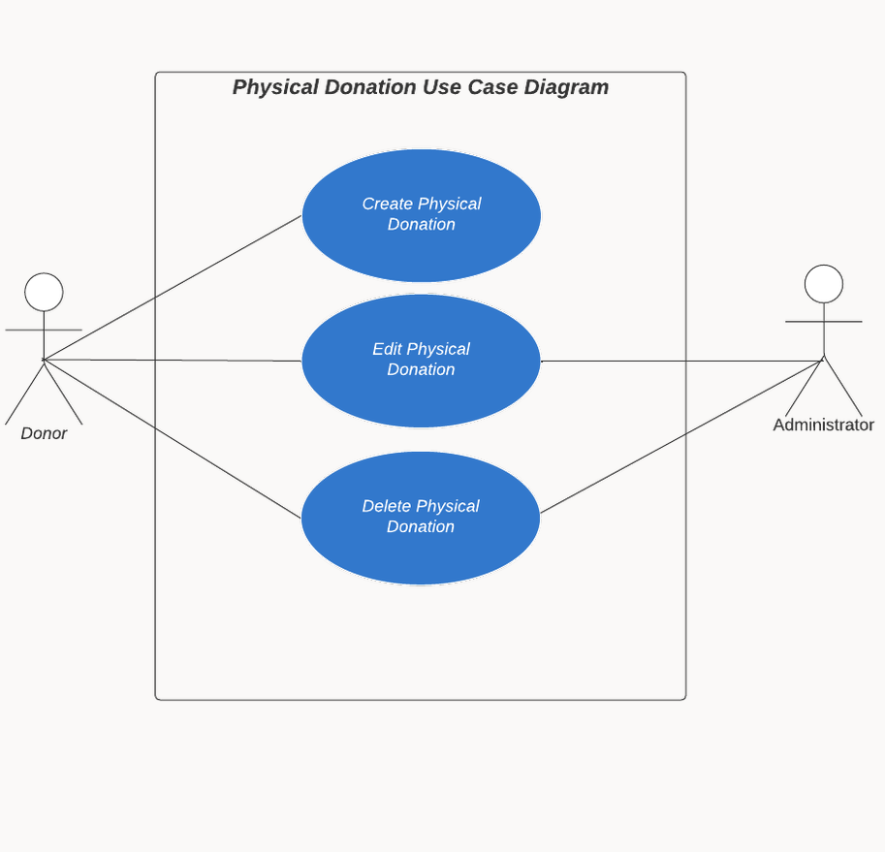

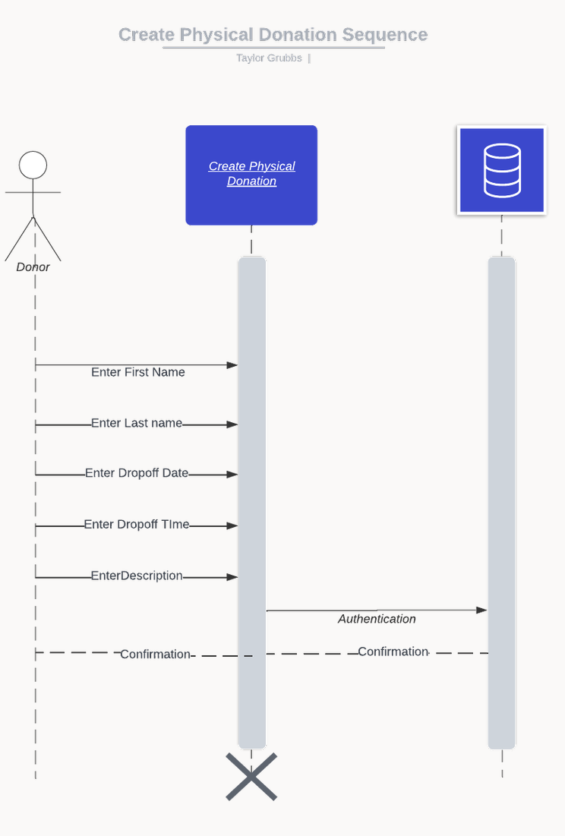

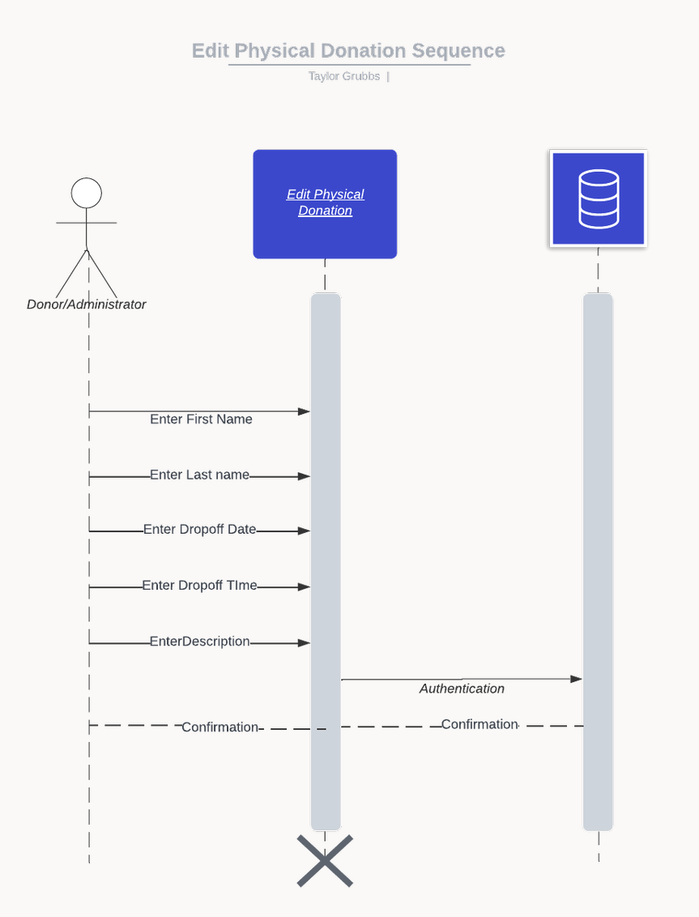

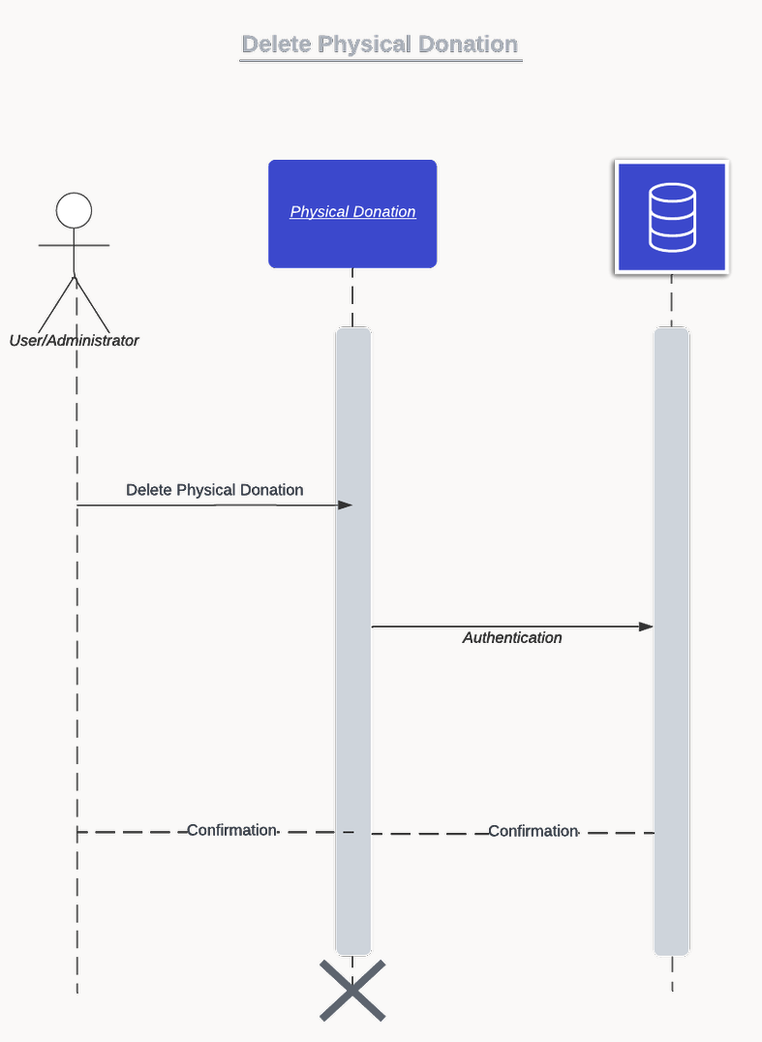

GRANT DIAGRAMS:
