Group member names: Jessye Hays, Rakan Alharbi, William Jamison, Zach Gonzalez, Wesley Gale
Exercise 9: Problem Solving (10 points)
Instructions:
- This is a group assignment. You only need to submit one solved exercise per group.
- You would only submit your SQL statements one single PDF file. If there are any notes you would like me to look at, please include those with the SQL statement.
- Every group member needs to run the SQL statements in their account. I have access to your database and will examine the individual work done.
- Once finished, upload the file to the appropriate assignment response in blackboard.
- You may upload as many attempts as you may like. Please note that only the most recent file uploaded file would be graded.
- Do not handwrite any responses.
- If you have any additional information you would like me to know about this assignment, you may provide that to me at the end of this document as a note.
Use the data model shown at the bottom of this document for this assignment:
What to do:
- This assignment must be completed in SQL Server. No other DBMS is allowed.
- All SQL statements written by different team members should be collated in this one single document in its appropriate area. No exceptions.
- Write a query for each of the following questions. The tables are in a database called PET. You can access the tables by qualifying the tables as in the following example: SELECT * FROM PET..CUSTOMER
- Copy paste these SQL statements in appropriate space in one single document.
- ERD for the database is provided at the end of this document.
- You would not create/copy this database into your account. It is included in your schema and you would access it following instructions in #3 above.

Assignment:

- Which merchandise items have an average sale price more than 50 percent higher than their average purchase cost?
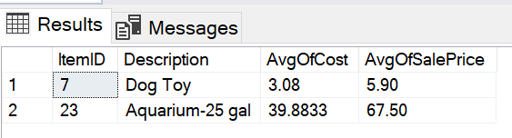

CREATE VIEW VCOST AS
SELECT ITEMID, AVG(COST) AS AVGCOST
FROM PET..ORDERITEM
GROUP BY ITEMID

CREATE VIEW VSALE AS
SELECT ITEMID, AVG(SALEPRICE) AS AVGOFSALEPRICE
FROM PET..SALEITEM
GROUP BY ITEMID

SELECT * FROM VSALE
SELECT * FROM VCOST

SELECT M.ITEMID, M.DESCRIPTION, C.AVGCOST, S.AVGOFSALEPRICE
FROM VCOST C INNER JOIN PET..MERCHANDISE M ON C.ITEMID = M.ITEMID
WHERE S.AVGOFSALE PRICE > 1.5 * C.AVGCOST

- On average, which supplier charges the highest shipping cost as a percent of the merchandise order total. OrderTotal is Sum(Quantity*Cost) and PctShipCost is Avg(ShippingCost/OrderTotal)?

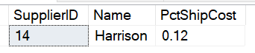
CREATE VIEW POCOST AS
SELECT PONUMBER, ROUND(SUM(QUANTITY*COST),2) AS PONUMTOTAL
FROM PET..ORDERITEM
GROUP BY PONUMBER

CREATE VIEW AVGSHIPCOST AS
SELECT SUPPLIERID, AVG(M.SHIPPINGCOST/PCT.PONUMTOTAL) AS PCTSHIPCOST
FROM PET..MERCHANDISEORDER M
INNER JOIN POCOST PCT ON M.PONUMBER = PCT.PONUMBER
GROUP BY SUPPLIERID

SELECT * FROM POCOST
SELECT * FROM AVGSHIPCOST

SELECT TOP 1 ASCT.SUPPLIERID, S.NAME, PCTSHIPCOST
FROM AVGSHIPCOST ASCT
INNER JOIN PET..SUPPLIER S ON S.SUPPLIERID = ASCT.SUPPLIERID
ORDER BY PCTSHIPCOST DESC

- Which customer has given us the most total money for animals and merchandise? SumofSalePrice is total money from animal sales given by sum(SalePrice). MerchTotal is total money from Merchandise sale given by Sum(Quantity*SalePrice). GrandTotal is SumofSalePrice added with MerchTotal. You may want to use ISNULL function to convert null values to zero. This is important because if a customer has SumofSalePrice as null while MerchTotal is not null, the addition of the two would be null. After all, any number + NULL = NULL. (ISNULL(MerchTotal,0)+ISNULL(SumOfSalePrice, 0)) AS GrandTotal

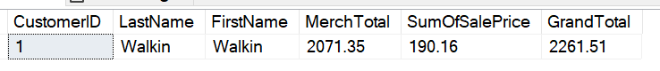
SELECT TOP 1 C.CustomerID, C.LastName, C.FirstName, SUM(ISNULL(SI.MerchTotal, 0)) AS MerchTotal, SUM(ISNULL(SA.SumOfSalePrice, 0)) AS SumOfSalePrice, SUM(ISNULL(SI.MerchTotal, 0)) + SUM(ISNULL(SA.SumOfSalePrice, 0)) AS GrandTotal
From PET..Sale S
Inner Join PET..Customer C ON S.CustomerID = C.CustomerID
Left Join (SELECT SI.SaleID, SUM(SI.Quantity * SI.SalePrice) AS MerchTotal
From PET..SaleItem SI
Group BY SI.SaleID) SI ON S.SaleID = SI.SaleID
Left Join (SELECT SA.SaleID, SUM(ISNULL(SA.SalePrice, 0)) AS SumOfSalePrice
From PET..SaleAnimal SA
Group By SA.SaleID) SA ON S.SaleID = SA.SaleID
Group By C.CustomerID, C.LastName, C.FirstName
Order By GrandTotal DESC;

