Group member names: Zach Gonzalez, Jessye Hays, Rakan Alharbi, William Jamison, Wesley Gale.
Exercise 8: Problem Solving (10 points)
Instructions:
- This is a group assignment. You only need to submit one solved exercise per group.
- Provide your responses on this file, save it, and upload the file to the appropriate assignment response in blackboard.
- You may upload as many attempts as you may like. Please note that only the most recent file uploaded file would be graded.
- Do not handwrite any responses.
- If you have any additional information you would like me to know about this assignment, you may provide that to me at the end of this document as a note.
Use the data model shown at the bottom of this document for this assignment:
What to do:
- This assignment must be completed in SQL Server. No other DBMS is allowed.
- Even though this is a group assignment, every group member has to create the DB for this assignment in their assigned individual SQL Server account. Failure to do so would result in individual score of zero even if the group score is different.
- All SQL statements written by different team members should be collated in this one single document in its appropriate area. No exceptions.
- Create the SQL Server database using the exercise 8 DB.txt given with this assignment. You can copy paste all the SQL code from this text file into your database and run it to create the tables and insert data. You may have to drop tables with same names that you may have created for previous assignments.
- Copy paste these SQL statements in appropriate space in this document.

Assignment:

With the increasing popularity of e-books in the last decade, the CIS Department at College of Business developed the Free Access to Current Technology (FACT) library of ebooks. FACT is a collection of current technology ebooks for use by faculty and students. The department is wondering if the library was used enough, and if it was, they would update the books. The department needs your help in analyzing this historical data. Agreements with the publishers allow patrons to electronically check out a book, which gives them exclusive access to the book online through the FACT website, but only one patron at a time can have access to a book. A book must have at least one author but can have many. An author must have written at least one book to be included in the system, but may have written many. A book may have never been checked out, but can be checked out many times by the same patron or different patrons over time. Because all faculty and staff in the department are given accounts at the online library, a patron may have never checked out a book or they may have checked out many books over time. To simplify determining which patron currently has a given book checked out, a redundant relationship between BOOK and PATRON is maintained. The ERD for this system is shown at the bottom of this document and should be used to answer Problems presented here. For these problems, a figure of the correct output is provided for each problem. If the output of the query is very large, only the first several rows of the output are shown.

- Write a query that displays the book title, cost and year of publication for every book in the system.
SQL:

SELECT BOOK_TITLE, BOOK_COST, BOOK_YEAR
FROM BOOK;

- Write a query that displays the first and last name of every patron.
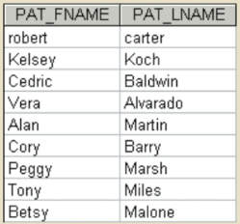
SQL:

SELECT PAT_FNAME, PAT_LNAME
FROM PATRON;

- Write a query to display the checkout number, checkout date, and due date for every book that has been checked out.
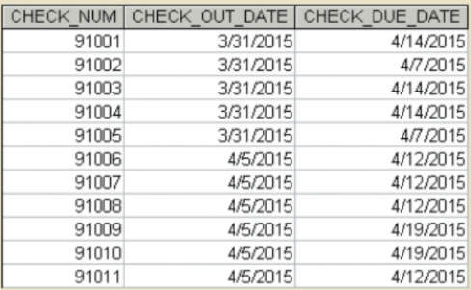
SQL:

SELECT CHECK_NUM, CHECK_OUT_DATE, CHECK_DUE_DATE
FROM CHECKOUT;

- Write a query to display the book number, book title, and year of publication for every book.
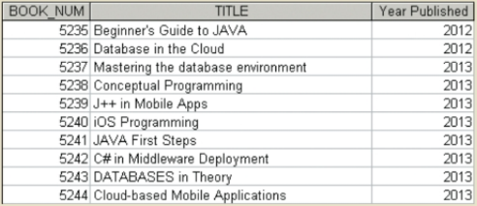

SQL:
SELECT BOOK_NUM, BOOK_TITLE, BOOK_YEAR
FROM BOOK;

- Write a query to display the different years in which books have been published. Include each year only once.
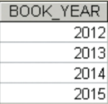
SQL:
SELECT BOOK_YEAR
FROM BOOK
GROUP BY BOOK_YEAR;

- Write a query to display the different subjects on which FACT has books. Include each subject only once.
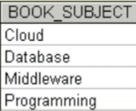
SQL:
SELECT DISTINCT BOOK_SUBJECT
FROM BOOK
ORDER BY BOOK_SUBJECT;

- Write a query to display the book number, title, and cost of each book.
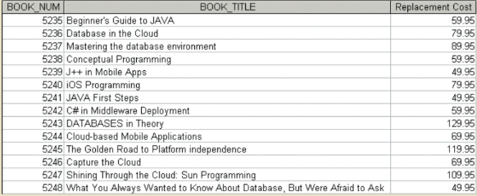
SQL:
SELECT BOOK_NUM, BOOK_TITLE,BOOK_COST
FROM BOOK
ORDER BY BOOK_NUM;

- Write a query to display the checkout number, book number, patron ID, checkout date, and due date for every checkout that has ever occurred in the system. Sort the results by checkout date in descending order.
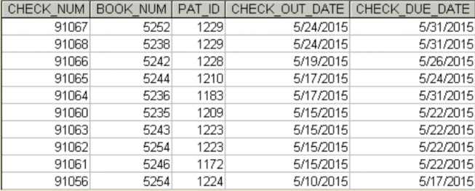
SQL:
SELECT CHECK_NUM, BOOK_NUM,PAT_ID, CHECK_OUT_DATE,CHECK_DUE_DATE
FROM CHECKOUT
ORDER BY CHECK_OUT_DATE DESC;

- Write a query to display the book title, year, and subject for every book. Sort the results by book subject in ascending order, year in descending order, and then title in ascending order.
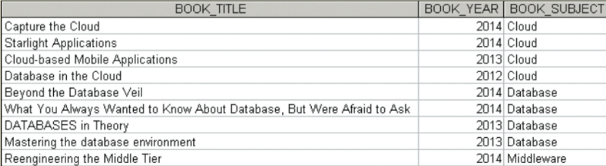
SQL:

SELECT BOOK_TITLE, BOOK_YEAR, BOOK_SUBJECT
FROM BOOK
ORDER BY BOOK_SUBJECT, BOOK_YEAR DESC, BOOK_TITLE;

- Write a query to display the book number, title, and year of publication for all books published in 2012.
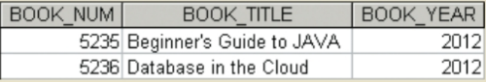
SQL:
SELECT BOOK_NUM, BOOK_TITLE, BOOK_YEAR
FROM BOOK
WHERE BOOK_YEAR = 2012;

- Write a query to display the book number, title, and year of publication for all books in the “Database” subject.
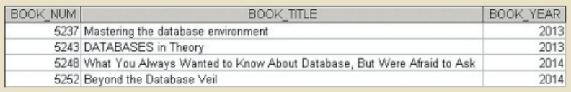

SQL:
SQL: SELECT BOOK_NUM, BOOK_TITLE, BOOK_YEAR FROM BOOK WHERE BOOK_SUBJECT = 'Database';

- Write a query to display the checkout number, book number, and checkout date of all books checked out before April 5, 2015.
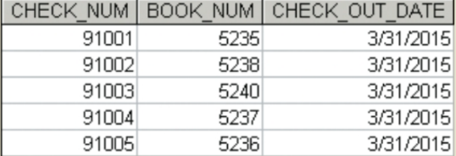
SQL:
SQL: SELECT CHECK_NUM, BOOK_NUM, CHECK_OUT_DATE FROM CHECKOUT WHERE CHECK_OUT_DATE < '2015-04-05';

- Write a query to display the book number, title, and year of publication of all books published after 2013 and on the “Programming” subject.
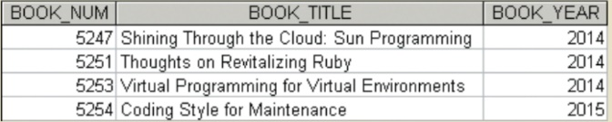
SQL:
SQL: SELECT BOOK_NUM, BOOK_TITLE, BOOK_YEAR FROM BOOK WHERE BOOK_YEAR > 2013 AND BOOK_SUBJECT = 'Programming';

- Write a query to display the book number, title, year of publication, subject, and cost for all books that are on the subjects of “Middleware” or “Cloud,” and that cost more than $70.
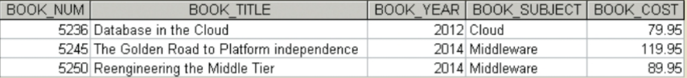
SQL:
SQL: SELECT BOOK_NUM, BOOK_TITLE, BOOK_YEAR, BOOK_SUBJECT, BOOK_COST FROM BOOK WHERE (BOOK_SUBJECT = 'Middleware' OR BOOK_SUBJECT = 'Cloud') AND BOOK_COST > 70;

- Write a query to display the author ID, first name, last name, and year of birth for all authors born in the decade of the 1980s.
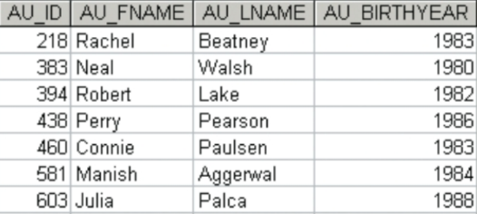
SQL:
SQL: SELECT AU_ID, AU_FNAME, AU_LNAME, AU_BIRTHYEAR FROM AUTHOR WHERE AU_BIRTHYEAR BETWEEN 1980 AND 1989;

