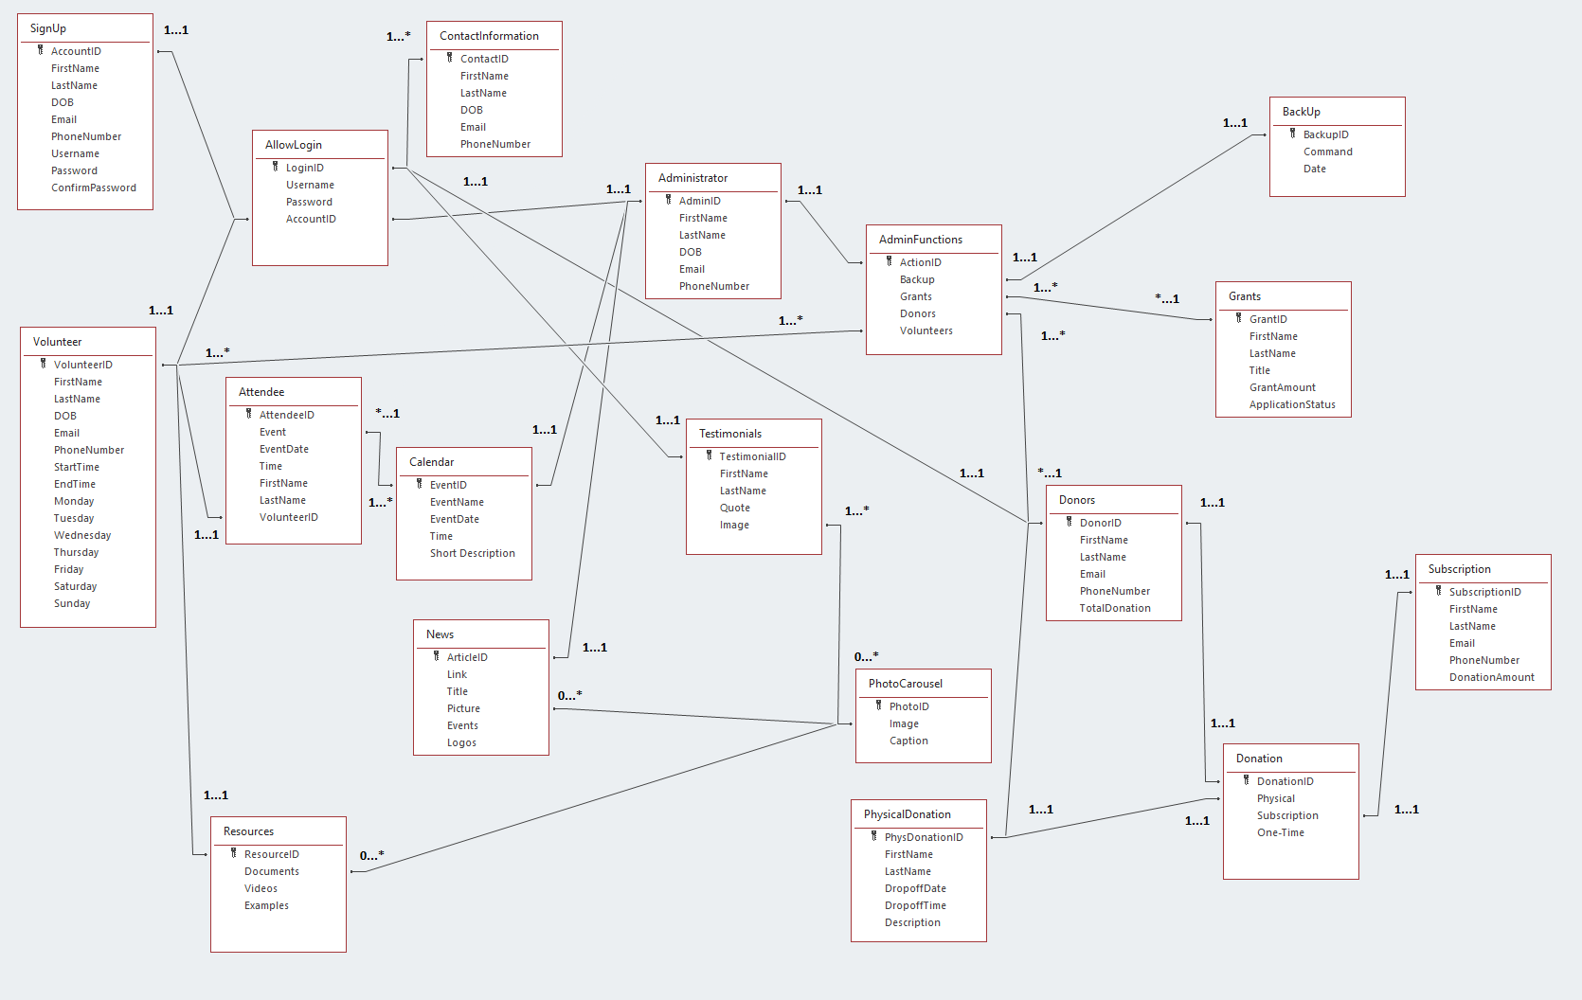
In the following relational database management system, the Entity Relationship Diagram has been modified and formatted into 3rd Normal Form (3NF). 3NF has been utilized to prevent data redundancy and to display the flow of data and relationships between classes without transitive and partial dependencies. Cardinality above the respective relationships has been used to represent the possible quantity of class instances during system processes.

